CHAPTER ONE
1.1 History of student industrial work experience scheme (SIWES)
Students Industrial Work Experience Scheme (SIWES) is the accepted skills training programme, which is an approved part of the Minimum Academic Standard (MAS) in the various degrees programmes for all Nigerian Universities. It is an effort to bridge the gap existing between the theory and practical among products of Nigerian Tertiary Institutions. It was established and funded by the Federal Government to expose undergraduates in Engineering, Technology and Sciences of Tertiary Institutions to the industrial environment so as to acquire basic skills existing in their respective disciplines to enhance their entry into industrial practices on completion of their studies and also reduce periods spent in training fresh graduates as new employees.
It was initiated and funded by the Industrial Training Fund (ITF) during the formative years (1973/1974). As a result of the increasing number of students enrolling in higher institutions, the administration of this function of funding the scheme became enormous, hence ITF withdrew from the scheme in 1978. It was taken over by the Federal Government in 1979 and handed it over to both the National University Commission (NUC) and the National Board for Technical Education (NBTE). By 1979, the Colleges of Education were not part of the scheme and later in 1984, the Federal Government reverted back to the Industrial Training Fund (ITF) which took over the Scheme officially in 1985 with funding provided by the Federal Government. The Scheme is a tripartite programme, involving the Students, the Universities and the Industry (employers of labour).
1.2 Aim of SIWES.
SIWES is aimed at exposing students to real life working environment, enabling them to put into practice the theories they have being thought, making them understand the technical implication of their profession as well as teaching them competence, standard and professionalism.

1.3 Objectives of SIWES.
Specifically, the objectives of Students Industrial Work Experience Scheme (SIWES) are to:
- Provide an avenue for students in Nigerian Universities to acquire industrial skills and experience in their courses of study.
- Prepare students for the work situation they are likely to meet after graduation.
- Strengthens employer involvement in the entire educational process and prepare students for employment in industries.
- Provide students with an opportunity to apply their theoretical knowledge in real work situation, thereby bridging the gap between university work and actual practice.
- Make the transition from the university to the world of work easier, thus enhance students’ contacts for later job placement.
- Expose students to work methods and techniques in the handling of equipment and machinery that may not be available in school.
- Promote the desired technological knowhow required for the advancement of the nation.
- Create an avenue for students to experience real life work conditions and situations.
1.4 Brief history of the university of Ibadan zoological garden.
The University of Ibadan, Zoological Garden was established in Ibadan north local government area of oyo state in 1948. It was established primarily as Menagerie (where few species of animals were kept) to support teaching and research in the Department of Zoology of the university of Ibadan. The zoo was initially operated as a mini zoo until 1974, when the goal of making the zoo of international standard was achieved under the administration of Sir Bob Golden, a European, a curator and the Director of the zoo as at that time. Sir Bob Golden liased with some foreign countries in acquiring some species of wild animals like the Gorilla that was brought from Cameroon although its dead and embalmed now, the henya that was gotten from Kenya and some other animals.
Basically the University of Ibadan zoological garden, practices Ex- situ conservation which entails conservation of animals outside its natural habitat. This done to ensure the existence of these animals and to prevent some of the animals whose existence are endangered from going into extinction. The management does its best in providing a suitable habitat for these animals, feeding them with the right food for continuity of these species.
1.5 Zoo management structure
The management of the University of Ibadan zoological garden is paddled under the administration of a director appointed for a of tenure of two years from the zoology department, University of Ibadan. The director is elected from the zoo managing council which comprises a representative from the Vice-Chancellor’s office, the departments of veterinary medicine, zoology, wildlife and fisheries, the bursary and the Dean, faculty of science. During my training in the zoological garden we had a change of administration as Dr (Mrs) Olajumoke Morenikeji handed over the baton of power to the newly appointed director Dr Akindayo A.S. The director has the responsibility of implementing the board’s decisions. He also coordinates all units and all personnel in the Zoo for effective administration. The administration office comprises of the secretary and the clerks. They are responsible for all the administrative activities in the zoo. The zoo keeping units is made up of the curators, supervisors, senior and junior zoo keepers. The have the responsibility of seeing to the day to day up keep of the animals, they also make daily health observations which is directed to the supervisors in charge of each section. There is also the security unit who provide security for the animals, visitors and workers. The gardeners are those who render the service of keeping the zoo clean while the account unit takes control of the revenues generated from the zoo they are accountable to the university authority.

1.6 Aims and objectives of the university of Ibadan zoological garden.
The aims and objectives of the zoo include:
- Provides center for research and conservation study.
- Ensure the conservation of endangered species.
- Tourist attraction.
- Promote the desired knowledge of the public about these animals.

1.7 Methods of acquiring animals to the zoo.
- By birth.
- By purchase.
- Through donation.
- Exchange.
- Animals can be acquired through stray means: Animals that are gotten by accident or that are caught in the wild.

1.8 Organisational structure of the university of Ibadan zoological garden.
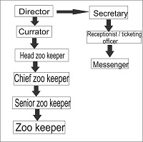

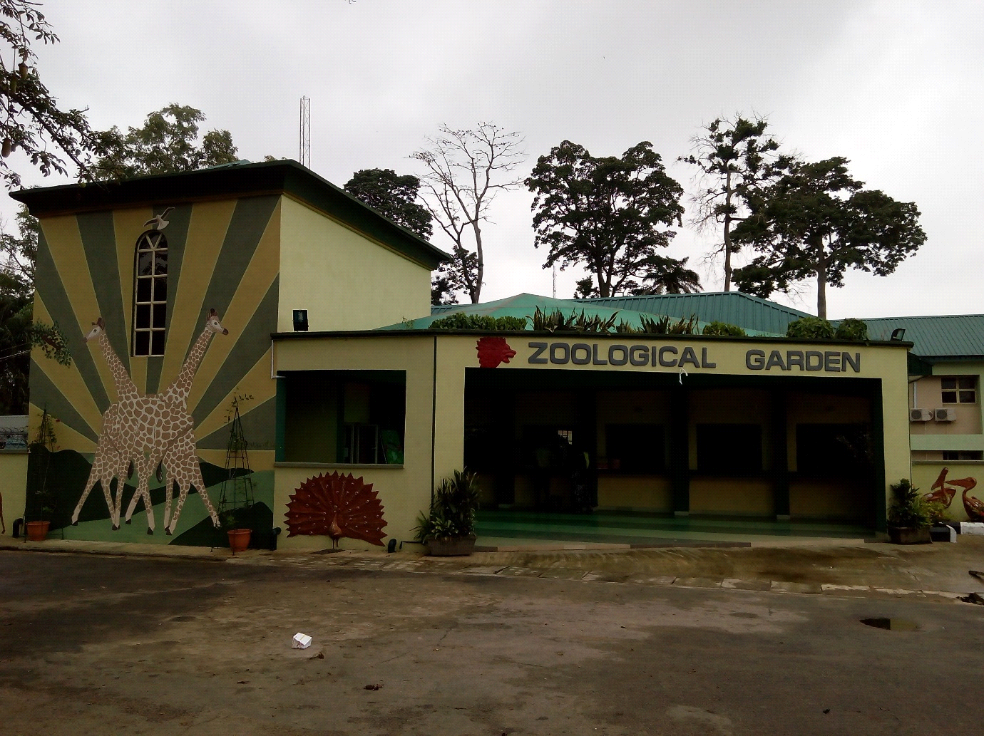
Plate 1:Front view of the university of Ibadan zoological garden.

CHAPTER TWO
2.1 General orientation
On resumption of my industrial training at the university of Ibadan zoological Garden, I met my industry based supervisor Mrs omolara Akande, who gave me an overview of the zoo, she told me about the six sections in the zoo which are Carnivore, Herbivore, Primate, Aviary, Omnivore and the Reptile sections.
I was introduced to the supervisors in charge of each of the sections, I was exposed to the animals and the kind of job I will be doing in each section. This orientation was important, as it helped me in developing a cordial relationship with each of the supervisors and it helped me in adeveloping a relationship with other Industrial training students I met as at my time of resumption.
The university of Ibadan zoological garden has 63 species of animals with over 275 animals in it. There are six sections in the zoo which include;
- Aviary section
- Carnivore section
- Reptile section
- Omnivore section
- Primate section
- Herbivore section
2.2 Aviary section
As the name implies aviary means a building for birds. The aviary is a large section that has houses diversity of different species of birds in it. It is divided into two other sections namely;
- Bird line
- Large birds
2.3 Bird line
The bird line is made up of 21 species of birds kept in separate enclosures with housing and enrichment suitable for their survival. Furthermore, they are divided into the carnivorous and Non-carnivorous birds.
Table 1:Carnivorous birds
S/N | Common Name | Binomial Name | Number in the zoo
1 | Brown pelican | Pelecanus occidentalis | 2
2 | Marabou stork | Leptoptilos crumenifer | 2
3 | Yellow billed kite | Milivus aegyptius | 3
4 | Palm nut vulture | Gypohierax angolensis | 1
5 | Common kestrel | Falco tinnuculus | 1
6 | Hooded vulture | Necrosyrtes monachus | 1
7 | Barn owl | Tyto alba | 3
8 | White stork | Balearica pavonina | 2

2.3.1 Brown pelican
Scientific Classification
Kingdom: Animalia
Phylum: Chordata
Class: Aves
Order: Pelecaniformes
Family: Pelecanidae
Genus: Pelecanus
Species: Pelecanus occidentalis
Conservation status: Least concerned
The brown pelican is best known and most prominent in the coastal areas of the southern and western parts of the United states. The brown pelican feeds by diving into water.

Description: Pelecanus occidentalis is a relatively large bird, it weighs from 2.75 to 5.5 kg and has a wingspan of between 1.83 to 2.5 m. It has a very large beak, with a gular pouch on the bottom for draining water when it scoops out prey. The head is white but often gets a yellowish wash in adult birds. The colour of its beak is in a form of yellowish white and the colour of its plumage is whitish grey. The back, rump, and tail are streaked with gray and dark brown, sometimes with a rusty hue.
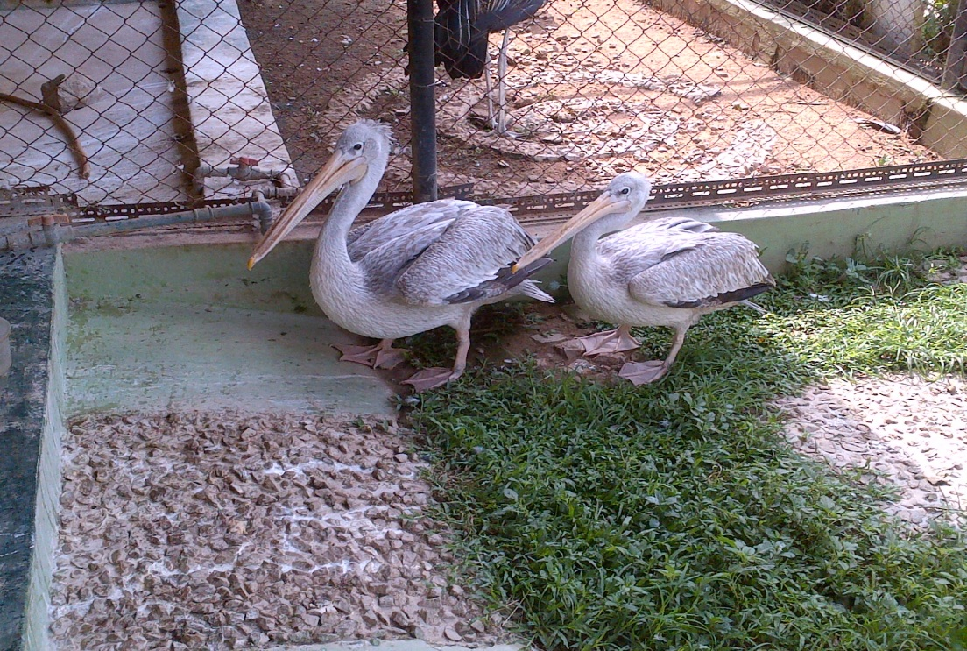
Plate 2: PICTURE OF THE BROWN PELICAN IN U.I ZOO
Housing and enrichment structure: The brown pelican in the zoological garden, University of Ibadan is housed in an enclosure that has a large water moat as it serves as enrichment to its habitat. Brown pelicans feed well with water as they scoop their prey from water even in the wild. Its enclosure also has its floor decorated with some gravels and the grasses are always kept low at all times to avoid exposing the animal to any form of danger. It’s enclosure is protected with a closely fit wire mesh to prevent visitors having direct contact with the animals and also to enable the bird have enough ventilation. Its enclosure has its roof covered with aluminium zinc to avoid exposing the animal to harsh weather conditions. The aluminium zinc was used as result of its durability and longevity, to avoid leakage and as a result predisposing the birds to health hazards.
Feeding: The brown pelicans are fed during the morning hours. They were fed with cat fish and the fish is cut into smaller portion and is thrown into water and they hunt for the fish themselves and sometimes I thrown the fish directly into their mouths and I make sure the fish is shared evenly among them. However, during my stay in this section there were times we didn’t always have cat fish and in these periods I fed them with liver from a freshly killed goat or cow. These periods when the pelicans were fed with the liver from a goat or cow as they case may be, the fed the four times weekly and when there was cat fish they were fed daily.
Behaviour: During my stay in this section, I observed that unlike other carnivorous birds they are friendly and calm .During feeding, I enter freely into the enclosure of the pelicans without any of the zookeepers accompanying me unlike other birds like the marabou stork because of its aggressive nature. During my training in this section I discovered whenever they are to be fed they just go straight to their water moat and wait for their food, while I put the food in the water moat for them to hunt for their food themselves or sometimes I throw the food to them directly into their mouths. During feeding, the male sometimes tries to overshadow the female by trying to eat more than her and part of the reason is because the female is suffering from cataracts in her left eye but I feed them in such that the female dosent feel cheated. Initially I always fed them under the supervision of Mrs Anozie the zoo keeper I work with but as time went on, I learnt how to feed them. I also learnt that pelicans are gregarious i.e they live in groups. They are exceptionally buoyant due to the internal air sacks beneath their skin and in their bones, and as graceful as they can be in the air they can be clumsy on land. In level flight, pelicans fly in groups, with their heads held back on their shoulders and their beak resting on their folded neck.

2.3.2 Palm nut vulture
Scientific classification
Kingdom: Animalia
Phylum: Chordata
Class: Aves
Order: Accipitriformes
Family: Accipitridae
Genus: Gypohierax
Species: Gypohierax angolensis
Conservation status: Least concerned
Description: The plumage of the palm nut vulture is all white except for black areas in its wings. It has a red patch around the eye. The immature ones which takes 3–4 years to mature, is brown with a yellow eye patch. In flight, it resembles an eagle more than a typical vulture, and it can sustain flapping flight, so it does not depend on thermals.
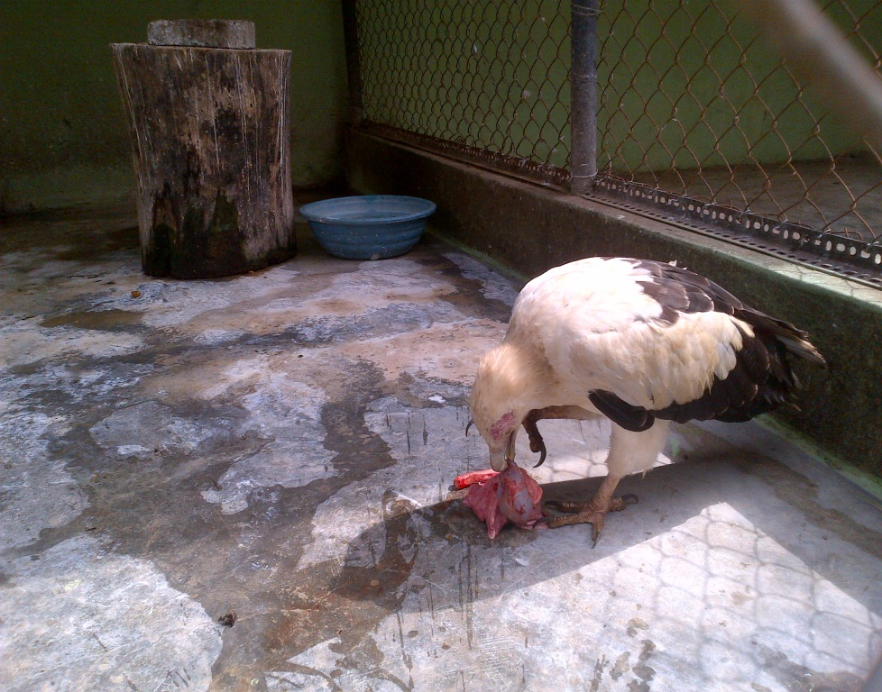
Plate 3: Picture of the palm nut vulture feeding on the lungs of a goat in U.I zoo

Housing structure: The enclosure of the palm nut vulture is built in a way that is friendly to the animal. The enclosure has some logs of wood of different sizes and height i.e some are high while some are low. The idea behind it, is that the bird can fly high and rest there at times especially when cleaning is going on in its enclosure. There is also a log of wood specially designed for putting its food especially when it doesn’t want to eat immediately. The floor of the enclosure is cemented there is also an iron railing that is built high in its enclosure. All these are done to enrich its habitat. Its enclosure is protected with wire mesh round it to prevent visitors, from having contact with the animal and also the wire mesh is designed for the animal to have adequate ventilation. Its roof is covered with aluminium zinc to prevent exposing the animal to harsh weather conditions. There is also a drinking bowl kept for the animal where drinkable water is served for the bird.
Feeding: At the University of Ibadan, zoological garden all carnivorous birds are fed four times in a week and that is Mondays, Wednesdays, Fridays and Saturdays. Palm nut vultures are carnivorous birds, though they fed mainly on the fruit of palm nut in the wild. That is where there name palm nut vulture is gotten from. During my training, I fed them with lungs from the goat or cow, depending on the one provided for the zoo. They also fed on day old chicks. They can consume up to 4 day old chicks a day. They are fed during the morning hours.
Behaviour: During my stay in this section, I observed the palm nut vulture to be a shy bird. Sometimes when it sees a new face is in its enclosure it feels threatened and tends to be restless, flying across the enclosure just to scare whomsoever is in its enclosure. I observed this, when I newly came to this section, and at first I felt uncomfortably especially when sweeping its enclosure though with time it stopped its restless attitude. I was taught by the zookeeper in charge of this section that whenever it behaves unfriendly to me and does as if its trying to attack me that I should just remain calm and when it sees that I have no ulterior motive for entering its enclosure it just flies up to the log the log of wood in the enclosure while I do my cleaning.
Table 2:Non carnivorous birds.
The non-carnivorous in the University of Ibadan, zoological garden are as follows:
S/N | Common Name | Binomial Name | Number in the zoo
1 | Senegal parrot | Piocephalus senegalus | 4
2 | Mallard duck | Anas platyyrhnchos | 1
3 | African grey parrot | Psittacus erithacus | 1
4 | Muscovy duck | Cairina moschata | 19
5 | White faced whistling duck | Dendrocygna viduata | 6
6 | Black crowned crane | Balearica pavonica | 3
7 | Spur winged goose | Plectropterus gambensis | 4
8 | Peafowl | Pavo cristatus | 6
9 | White peafowl | Paro cristatus | 1
10 | Speckled pigeon | Columba guinea | 5
11 | White geese | Chen caerulesucens | 3
12 | Budgerigar parrot | Melopsittacus undalatus | 3
13 | Quail | Coturnix coturnix | 5

2.3.3 Senegal parrot
Scientific classification
Kingdom: Animalia
Phylum: Chordata
Class: Aves
Order: Psittaciformes
Family: Psittacidae
Genus: Poicephalus
Species: Poicephalus senegalus
Conservation status: Least concerned
Taxonomy: There are three subspecies. They do not differ in behaviour, but only in the colour of the "vest". In the pet trade, the nominate subspecies is the most common, though all three are sold as pets.
- Poicephalus senegalus senegalus (the nominate subspecies): This subspecies has a yellowish green vest; its native range includes Senegal, southern Mauritania, southern Mali to Guinea and Lobos Island. This specie is present at the university of Ibadan zoological garden.
- Poicephalus senegalus mesotypus: This subspecies has an orange vest; its range is from eastern and northeastern Nigeria and Cameroon into southwest Chad.
- Poicephalus senegalus versteri: This subspecies has a deep-orange/red vest; its range is from the Ivory Coast and Ghana east to western Nigeria.
Description: Senegal parrots are about 23 cm long, weigh about 120 to 170 g. They have a relatively large head and beak for their overall size, and feathers form a short broad tail. They have a charcoal grey head, grey beak, bright yellow irises, green back and throat, and yellow under parts and rump. The yellow and green areas on a Senegal parrot's front form a V-shape resembling a yellow vest worn over green.
Senegal parrots are not sexually dimorphic, but there are some hypotheses which sometimes might help to determine the gender of adult birds:
- The V-shape of the vest is usually longer in females; in females the green area extends down over the chest to between the legs, whereas in males the tip of the green area ends midway down the chest.
- The female's beak and head are generally slightly smaller and narrower than the male's.
- Males are generally, but not always, larger and heavier than female birds.
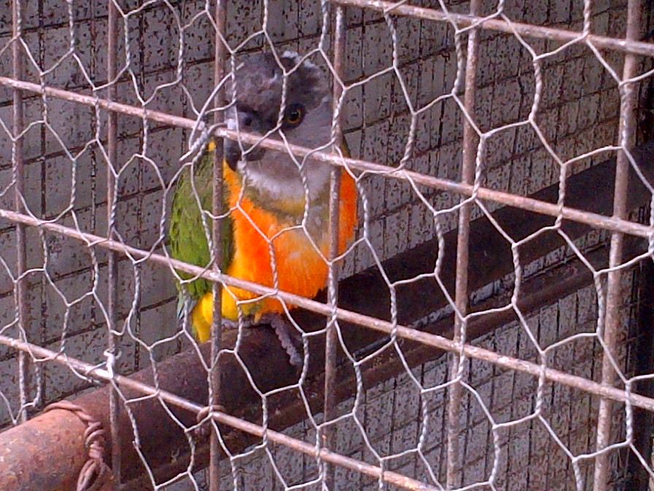
Plate 4: PICTURE OF A SENEGAL PARROT IN ITS CAGE AT U.I ZOO

Feeding: The Senegal parrots at the university of Ibadan zoological garden are fed with groundnut and dried pepper. The dried pepper is usually in higher proportion compared to the groundnut as they love eating dried pepper and sometimes in place of groundnut they are usually given corn mixed with raw guinea corn . Their food is deliberately changed at times to serve as balanced diet for the birds. They are sometimes fed with almond fruit as they love it. They are fed daily. There also a bowl in their cage where drinking water is served for them.
Behaviour: The Senegal parrot is quite a friendly bird as they can be used as pets in homes. Their calls are high pitched whistles and squawks along with mimics, but they are not as noisy as many other parrot species.
Life span: Senegal parrots live an average of approximately 25–30 years in the wild, and have been known to live for 50 years in captivity.
Housing structure: At the university of Ibadan zoological garden the Senegal parrots are housed in an enclosure made of iron designed with wire mesh around it. It also has its roof covered with aluminium zinc. In the cage there is an iron railing that is hanged up in the cage that is beautifully designed for the birds to perch when there cage is being swept and sometimes they perch on the iron railings when they want to rest.

2.3.4 Mallard duck
Scientific classification
Kingdom: Animalia
Phylum: Chordata
Class: Aves
Order: Anseriformes
Family: Anatidae
Genus: Anas
Species: Anas platyrhynchos
The mallard or wild duck (Anas platyrhynchos) is a dabbling duck which breeds throughout the temperate and subtropical Americas, Europe, Asia, and North Africa, and has been introduced to New Zealand, Australia, Peru, Brazil, Uruguay, Argentina, Chile, the Falkland Islands and South Africa. This species is the main ancestor of most breeds of domesticated ducks.
Description: The mallard duck is a medium-sized waterfowl species although it is often slightly heavier than most other dabbling ducks. It is 50–65 cm long (of which the body makes up around two-thirds), has a wingspan of 81–98 cm , and weighs 0.72–1.58 kg .The male mallard (drakes) have a glossy green head and are grey on wings and belly, while the females (hens or ducks) have mainly brown-speckled plumage. The rear of the male is black, with the dark tail having white borders. The beak of the male is a yellowish orange tipped with a little black while that of the female is generally darker ranging from black to mottled orange. 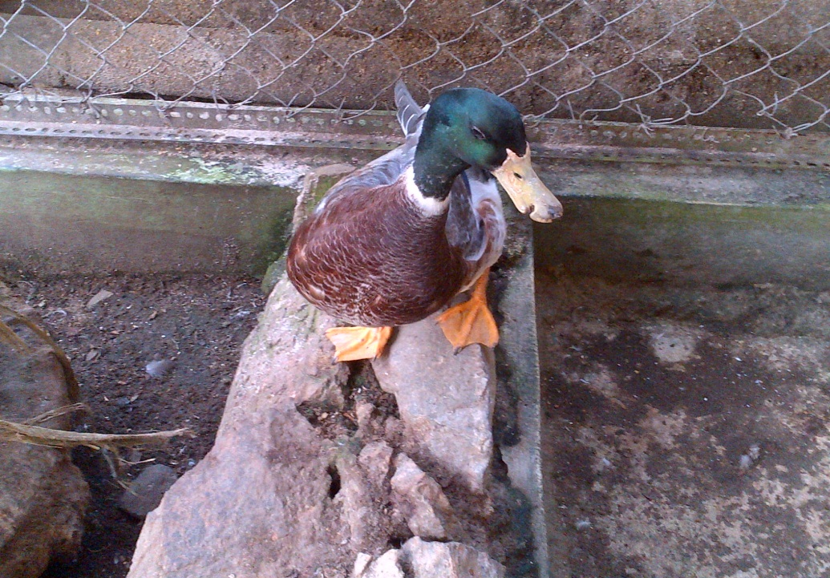
Plate 5: Picture of the Mallard duck showing its yellowish orange beak.
Housing structure: The enclosure of the mallard duck in the university of Ibadan zoological garden is beautifully designed for the bird. It has a relatively large water moat for the duck as it loves to swim. There is also an un-cemented floor in its enclosure, here food and water is kept for the animal in a metal wide bowl. The position of the food is regularly changed as it helps the animal to move around in its enclosure. Its enclosure is protected with wire mesh round it, as it also enables the animal to have enough air. The roof is covered with aluminium zinc from exposing the duck to harsh weather conditions.
Feeding: During my stay in the aviary section, the mallard duck was fed with compounded feed. This compounded feed is special food for the non-carnivorous birds at the university of Ibadan zoological garden. The compounded feed is a combination of various feed mixed together it includes bean shaft, sorghum, wheat etc. This compounded feed is usually bought from the market and served to these birds. It feeds daily, and apart from the compounded feed, it is usually given corn mixed with guinea corn. There is a water bowl for it where drinking water is usually served for the duck. Although it gets water from its water moat when swimming but the drinking bowl is always kept for the animal as their a few times in the zoo where water is not provided for the animal in its moat due to failure of power supply in the university and those few times the animal makes use of the water served in its drinking bowl for drinking.
Behaviour: During my stay in this section, I observed the animal to be a calm bird. It has an ability to adapt easily. My reason is that, during my stay in this section, some Muscovy ducks were transferred to its enclosure because of the increase in the number of the Muscovy ducks due to their birth rate. This was done in the interest of the Muscovys to avoid over-crowding. I observed that the mallard duck was able to accommodate these muscvoy ducks, as they were able co-habitat the same environment without having to fight over anything.
2.3.5 Large birds
In the large bird section are there are two species of large birds which are shown in the table below:
Table 3: LARGE BIRDS
S/N | Common Name | Binomial Name | Number in the zoo
1 | Ostrich | Struthio camelus | 3
2 | Emu | Dromaius novaehollandiae | 1

2.3.6 Emu
Scientific Classification
Kingdom: Animalia
Phylum: Chordata
Class: Aves
Order: Casuariiformes
Family: Dromaiidae
Genus: Dromaius
Species: Dromaius novaehollandiae
Dromaius novaehollandiae is the second-largest living bird in the world, after its ratite relative, the ostrich. It is endemic to Australia where it is the largest native bird and the only extant member of the genus Dromaius. The emu's range covers most mainland of Australia. The bird is sufficiently common as it is rated as a least-concern species by the International Union for Conservation of Nature.
Breeding for the emu takes place in May and June, and fighting among females for a mate is common. Females can mate several times and lay several clutches of eggs in one season. The male does the incubation; during this process he hardly eats or drinks and loses a significant amount of weight. The eggs hatch after around eight weeks, and the young are nurtured by their fathers. They reach full size after around six months, but can remain as a family unit until the next breeding season. The emu is an important cultural icon of Australia, appearing on the coat of arms and various coins. The bird features prominently in Indigenous Australian mythology.
Description: The emu is the second largest bird in the world, only being exceeded in size by the ostrich .Its weighs between 18 and 60 kg. From research I discovered that female is usually slightly larger than the male and is substantially wider across the rump. It has three toes on each foot in a tridactyl arrangement, which is an adaptation for running. Although flightless, it has vestigial wings, each wing has a small claw at the tip. It flaps its wings when running. It has relatively long neck and legs, and can run at speeds of 48 km/h (30 mph) due to its highly specialized pelvic limb musculature. Its legs are devoid of feathers and underneath its feet are thick. It has sharp claws on its toes which are its major defensive attribute, and are used in combat to inflict wounds on opponents by kicking. It has good eyesight and hearing ability, which allows it to detect threats at some distance. The neck of the emu is pale blue and has sparse feathers. It has a grey-brown plumage of shaggy appearance, the shafts and the tips of its feathers are black.
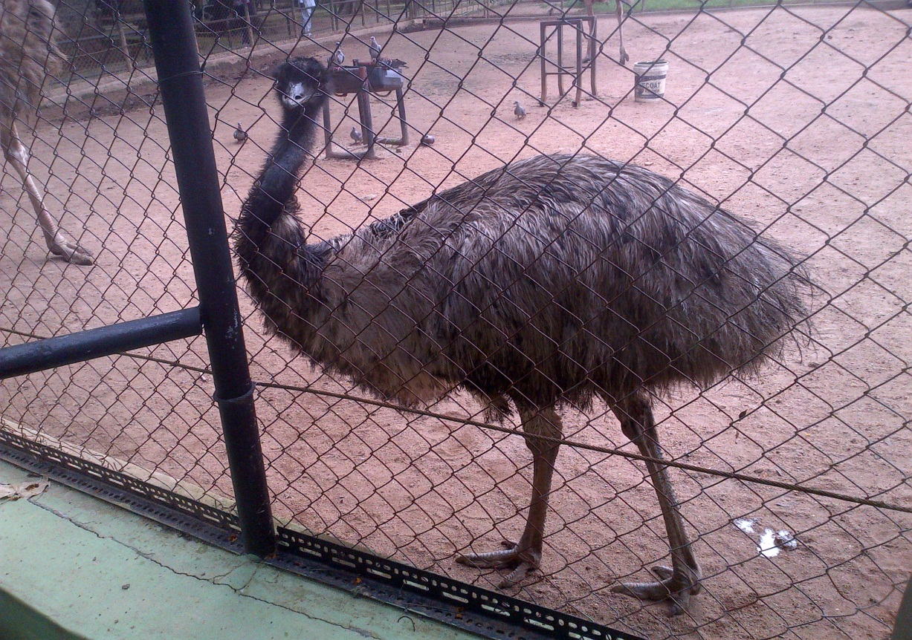
Plate 6: Picture of an Emu in its enclosure.

Housing structure: Emus are most common in areas of sclerophyll forest and savannah woodland. At the university of Ibadan zoological garden, the emu is housed in a relatively vast open land. The large area of land is surrounded with wire mesh and barb wire to serve as protection to it. Inside its enclosure there is building where made for it to go in when the weather is not favourable or to rest.
Feeding: Emus eat a variety of plant species such plants as Acacia, Casuarina and grasses. They also eat insects and other arthropods like grasshoppers, crickets, beetles, cockroaches, ladybird, ants, spiders and millipedes because of its nature to forage. At the university of Ibadan zoological garden, it was fed with compounded feed; that includes assorted kinds of feeds like bean shaft, sorghum, millet, bone meal etc all mixed together specially designed for it. It also has a water bowl where drinking water is kept for it. The emu is also given vitamix a multivitamin twice every week. This vitamix is usually mixed in its drinking water.
Behaviour: During my training I discovered that the emu is a diurnal bird. It spends most of its day foraging, preening its plumage with its beak, dust bathing and resting. I also learnt from my supervisor that in the wild, emus are generally gregarious birds apart from the breeding season, while some forage, others remain vigilant to their mutual benefit. They are also able to swim when necessary, although they rarely do so unless the area is flooded or they need to cross a river.
2.3.7 General sanitation done in the aviary section
As part of my daily routine when I was working at the aviary section. The following was done by me and other industrial training students I was working with during my stay in this section.
- I sweep the enclosures of these birds daily, wash their feed and drinking bowls. For water birds their moats are washed and water changed once every week.
- While sweeping the enclosures of these birds as part of how I was trained I remove any cobwebs found on the wire mesh of their enclosures.
- Once in two weeks, for birds whose enclosures are cemented I wash their enclosures intensively with chlorine to remove germs.
- Cleaning of over grown grasses for those birds that have their enclosures designed with grasses.
- While sweeping their enclosures left over foods are always disposed.
- In the cause of the sweeping and cleaning the faeces of the birds are properly removed and their enclosures properly washed.

2.3.8 Precautionary measures taken during cleaning
As part of my training, I was taught that during cleaning, there are certain measures that must be strictly adhered to in order to avoid any unforeseen harm that can endanger these birds as a result of not adhering to them. And these precautionary measures are:
- When in the enclosure of any of the birds, the door must be properly locked in order to prevent the bird from escaping.
- The equipment used for working must be put in a place the animal cannot have access to prevent the animal from being injured. And in some worse cases these may even lead to the death of the bird as a result of it maybe swallowing a harmful object.
2.3.9 General care for the birds
As part of the care measures taken in keeping these birds healthy and free from diseases the following are done regularly:
- They are dewormed once in two months while some other birds like the marabou stork, brown pelicans etc are dewormed once in three months. These is used done based on the prescription of the veterinary doctors working with zoo. The drugs used in deworming include zodex whose main component is mebendazole, zodex was used in deworming marabou stork, hooded vulture white peafowl and others. They were also dewormed with ivermec this was used in deworming some other birds like the brown pelican, Senegal parrot, African grey parrot and others. The deworming was done by the veterinary doctors working with the zoo.
- Three times in a week their food or water as the case may be for is usually mixed with a multivitamin called vitamix. Vitamix is combination of vitamins, electrolytes and amino acids. It aids growth and performance, it also aids in recovery from diseases and it helps to combat dehydration. This is done mainly for the non- carnivorous birds.
- Since their enclosure is mostly surrounded with wire mesh and barb wire. It is prone to damage as these birds usually perch or beak on it. Once the damage of the wire mesh is discovered, it usually fixed, as a new one is put to prevent these birds from getting injured by the wire mesh or even escaping.

2.4 Reptile section
Reptiles are cold blooded animals and they have their bodies covered in scales. Although some maintain a dual habitat e.g crocidiles, they can live both on land and in water.
Reptiles at the university of Ibadan zoological garden are housed at special building called the serpentarium otherwise known as the reptile house. The serpentarium houses different species of snakes, monitor lizards, crocodiles, turtles and so on. There are 12 species of reptiles at the reptile section although at reptile section, snails are being reared here under the auspices of the reptile but are not reptiles as they fall under the phylum Mollusca.

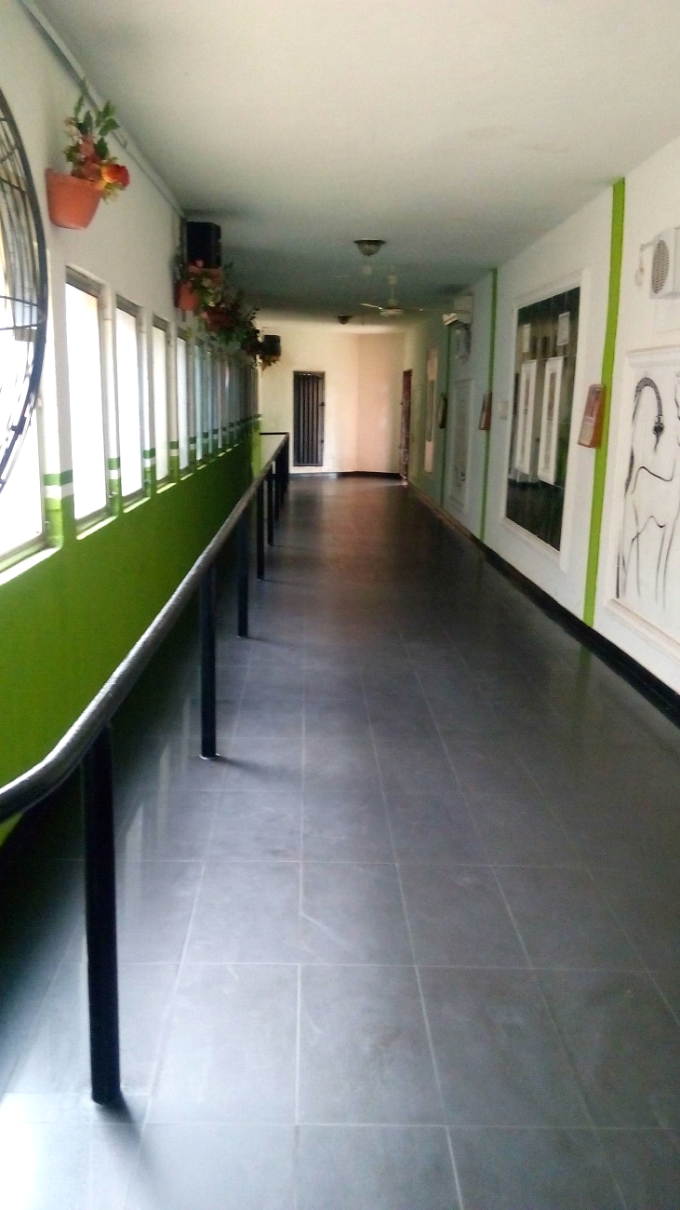
Plate 7: A picture showing the serpentarium at U.I zoo

Table 4: Reptiles
S/N | Common Name | Binomial Name | Number in the Zoo
1 | African rock python | Python sebae | 2
2 | Gaboon vipers | Bitis gabonica | 1
3 | Royal python | Python regius | 4
4 | African soft shell turtle | Trionyx triunguis | 3
5 | Night adder | Causus rhombeatus | 1
6 | West African mud turtle | Pelusios castaneus | 29
7 | Black neck spitting cobra | Naja nigricollis | 1
8 | Black cobra | Naja naja | 1
9 | Giant land tortoise | Testudo gracea | 27
10 | Dwarf crocodile | Osteolaemus tetraspis | 6
11 | Monitor lizard | Varanus albigularis | 2
12 | Nile crocodile | Crocodylus niloticus | 7 adults and still counting
2.4.1 AFRICAN ROCK PYTHON
Scientific classification
Kingdom: Animalia
Phylum: Chordata
Class: Reptilia
Order: Squamata
Suborder: Serpentes
Family: Pythonidae
Genus: Python
Species: Python sebae
The African rock python (Python sebae) is a large, nonvenomous snake of sub-Saharan Africa. It has two subspecies; one is found in Central and Western Africa, the other in Southern Africa.
It is africa’s largest snake and one of the six largest snake species in the world (along with the green anaconda, reticulated python, Burmese python, Indian python, and amethystine python), specimens may approach or exceed 6 m (20 ft). The African rock python kills its prey by constriction and often eats animals up to the size of antelope, occasionally even crocodiles. The snake reproduces by egg-laying. Unlike most snakes, the female protects her nest and sometimes even her hatchlings.
Description: It is africa's largest snake species and one of the world's largest, the typical African rock python adult measures 3 to 3.53 m (9 ft 10 in to 11 ft 7 in), with only unusually large specimens likely to exceed 4.8 m (15 ft 9 in).
The African rock python's body is thick and covered with coloured blotches, often joining up in a broad, irregular stripe. Body markings vary between brown, olive, chestnut, and yellow, but fade to white on the underside. The head is triangular and is marked on top with a dark brown “spear-head” outlined in buffy yellow. Teeth are many, sharp, and backwardly curved. Under the eye, there is a distinctive triangular marking, the subocular mark. The scales of the African rock python are small and smooth. Scales around the lips possess heat-sensitive pits, which are used to detect warm-blooded prey, even in the dark. Pythons also possess two functioning lungs, unlike more advanced snakes which have only one, and also have small, visible pelvic spurs, believed to be the vestiges of hind limbs.
Housing structure: The African rock python inhabits a wide range of habitats, including forest, savanna, grassland, semi-desert, and rocky areas. At the university of Ibadan zoological garden, the African rock python is housed in a large enclosure designed with some shrubs, flowers and grasses in it. There a large bowl in form of a water moat where there snake drinks from at times the snake coils itself in the bowl.
Feeding: During my stay in this section, I fed the bigger African rock python with ( 6 )day old chicks and the smaller African rock python was fed with (4 )day old chicks. They are fed once a week precisely on Tuesdays. Sometimes the bigger African rock python is being fed with live chicken. The African rock python is non-venomous and kills its prey by constriction. After gripping the prey, the snake coils around it, tightening its coils every time the victim breathes out. Death is thought to be caused by cardiac arrest rather than by asphyxiation or crushing. However, in the wild the African rock python feeds on a variety of large rodents, monkeys, warthog, antelopes, bats, monitor lizards and even crocodiles in forest areas, and on rats, poultry, dogs and goats in suburban areas.
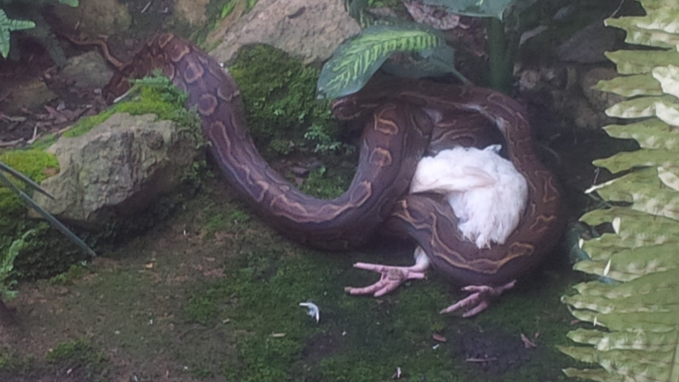
Plate 8: An African rock python constricting a fowl at U.I zoo

2.4.2 Nile crocodile
Scientific classification
Kingdom: Animalia
Phylum: Chordata
Class: Reptilia
Order: Crocodilia
Family: Crocodylidae
Genus: Crocodylus
Species: Crocodylus niloticus
Description: The Nile crocodile (Crocodylus niloticus) is a supremely adapted aquatic predator, with a streamlined body, a long powerful tail, webbed hind feet, and long powerful jaws, ideally suited for grabbing and holding onto prey. The eyes, ears and nostrils are located on top of the head, allowing the crocodile to lie low in the water, almost totally submerged and hidden from prey. A special valve at the back of the throat allows the mouth to be opened to catch and hold prey underwater without water entering the throat.
In addition to a good sense of smell and excellent night vision, the Nile crocodile also possess sensory pits in the scales along the side of the jaw, used to detect movement and vibrations in the water. Like all true crocodiles, the enlarged fourth tooth on the lower jaw is clearly visible when the mouth is closed, a feature which distinguishes this group from other crocodilians, such as alligators.
The body of the adult Nile crocodile is a grey-olive colour, with a yellowish belly, while the juvenile is more greenish or dark olive-brown, with black cross-banding on the tail and body, which becomes fainter in adults. In general, the male Nile crocodile grows larger than the female. On average, the adult male Nile crocodile is between 3.5 and 5 m (11 ft 6 in and 16 ft 5 in) in length and weighs 225 to 750 kg. Sexual dimorphism is prevalent, and females are usually about 30% smaller than males. They have a thick scaly skin that is heavily armored.
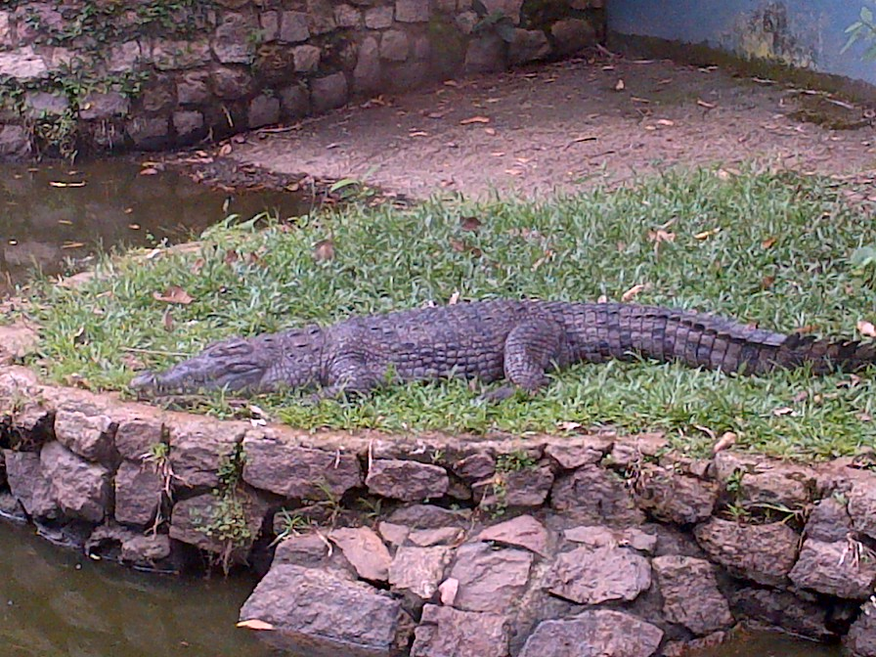
Plate 9: A Nile crocodile in its abode at U.I zoo

Housing structure: At the university of Ibadan zoological garden the nile crocodiles, are housed at different places as there are a lot of Nile crocodiles there. There is a place called the crocodile village, here it is a large body of water that is about 14 ft deep and there is wide area of land in the middle because the crocodile village is built in such a way the dry land is in the middle surrounded by water. Sometimes these crocodiles come out to the dry land to bask under the sun for hours. There is also another large water moat that that houses only two crocodiles. At the crocodile village, the number of crocodiles here are inestimable due to their high increase in birth rate. Crocodiles maintain a dual habitat i.e they can live both on land and in water. In their respective houses there is a large body of water made available to them and also a dry land is also made available for them.
Behaviour: Nile crocodiles are relatively inert creatures as they can spend hours, if not disturbed continuously basking with their jaws open if conditions were sunny. Research has shown that If their jaws are bound together in the extreme midday heat, Nile crocodiles may easily die from overheating. Although they can remain practically motionless for hours on end whether basking or sitting in shallows, Nile crocodiles are constantly aware of their surroundings and aware of the presence of other animals. They are deft and agile swimmers when motivated. Nile crocodiles normally dive for only a few minutes at a time, but can swim underwater for up to 30 minutes if threatened, and if they remain fully inactive they can hold their breath for up to two hours. They have a rich vocal range, and good hearing. Nile crocodiles normally crawl along on their bellies, but they can also "high walk" with their trunks raised above the ground. Smaller specimens can gallop, and even larger individuals are capable on occasion of surprising bursts of speed, briefly reaching up to 12 to 14 km/h (7.5 to 8.7 mph). They can swim much faster by moving their bodies and tails in a sinuous fashion, and they can sustain this form of movement much longer than on land, with a maximum known swimming speed 30 to 35 km/h (19 to 22 mph), more than three times faster than any human.
Feeding: At the university of Ibadan zoological garden, the nile crocodiles are fed three times in a week, they are fed Mondays, Wednesdays and Fridays. They are fed with the intestine from the goat or cow killed for the carnivorous animals in the zoo. They intestine gotten from the goat or cow is cut into small bits and is thrown to the crocodiles in water. During my stay in this section, I sometimes fed the crocodiles but it was always under the supervision of the zookeeper in charge of this section. During my stay in this section, I observed that crocodiles are voracious feeders.
2.4.3 Black cobra
Scientific classification
Kingdom: Animalia
Phylum: Chordata
Class: Reptilia
Order: Squamata
Sub-order: Serpentes
Family: Elapidae
Genus: Naja
Species: Naja naja
Description: It is a venomous snake and best known for the hood its flares when it feels threatened or are about to strike. Black cobras are not necessarily black, and may also be olive-gray or any shade of brown. The back of its hood displays a distinctive pale yellow spectacled pattern. It grows 6 to 8 feet in length, becoming medium-sized adult snake with smooth patterned scales.
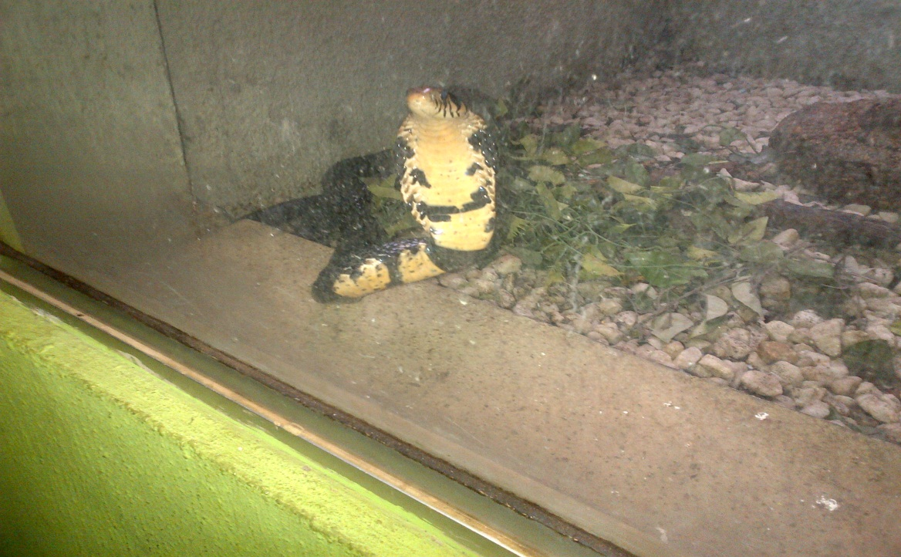
Plate 10: A Black cobra flaring its hood at U.I zoo.

Feeding: Basically, during my training the black cobra was fed with day old chicks. The black cobra can up to finish 4 day old chicks. Before the chicks are given to the snake, first we have to know the position of the snake in its enclosure, as its enclosure has a glass through which we can clearly see the snake as shown in the picture above. And if the snake is in a strategic place like around the door area we distract the snake by hitting door or the glass gently this will make the snake feel threatened and then distract the snake and will enable us throw the chicks into its enclosure, this is usually done quickly. Although during my training, I observed that in the morning hours when it is being fed, it usually stays close to the glass away from the door.
Housing structure: At the university of Ibadan zoological garden, the enclosure of the black cobra has a glass used to design the enclosure. The idea behind this is that, it will enable visitors have a clear view of snake and also the snake would not be to harm anyone. In its enclosure, it is enriched with some leaves and gravels are used as the floor and there is there is also a bowl made from stone where drinking water is kept for the snake.
Behaviour: The black cobra is a diurnal snake most active in the morning hours and in the evening. It is Quick and agile. When threatened, the black cobra raises the front third of its body, elongating its neck and flaring its skin to display its intimidating hood. If the threat continues despite the snake’s warning, its attack will be swift. Black cobras attack at full strength to defend themselves. They hold on and gnaw at their victim, and may strike repeatedly.
2.5 General sanitation done in the reptile section
During my stay in this section, as part of my daily and weekly routine the following was done by me and other industrial training I was working with.
- I sweep and mop the tiles around the serpentarium.
- Once in three weeks the crocodiles moat is washed with chlorine.
- I remove the cobwebs around the enclosures of the animals.
- I wash the intestine of the goat that is for the reptiles apart from the snakes intensely with water to remove any form of dirts in it.
- I clean the glass regularly to enable easy view of the reptiles.
As part of the care for the reptiles, they are dewormed once in three months, the drugs were injected into the chicks for the snakes and the other reptiles like the crocodiles, monitor lizards and the turtles that feed on flesh it was mixed in their food given to them.

2.6 Ration of food given to the reptiles
All the snakes feed on day old chicks and the chicks are apportioned to the snakes respectively according to their sizes and they fed once in a week. For the other reptiles apart from the giant land tortoise the feed on the internal part (i.e liver, kidney, intestine and lungs) of the goat or cow killed and they feed thrice weekly. The land tortoises are fed with yam mixed with or beans and they are fed daily.

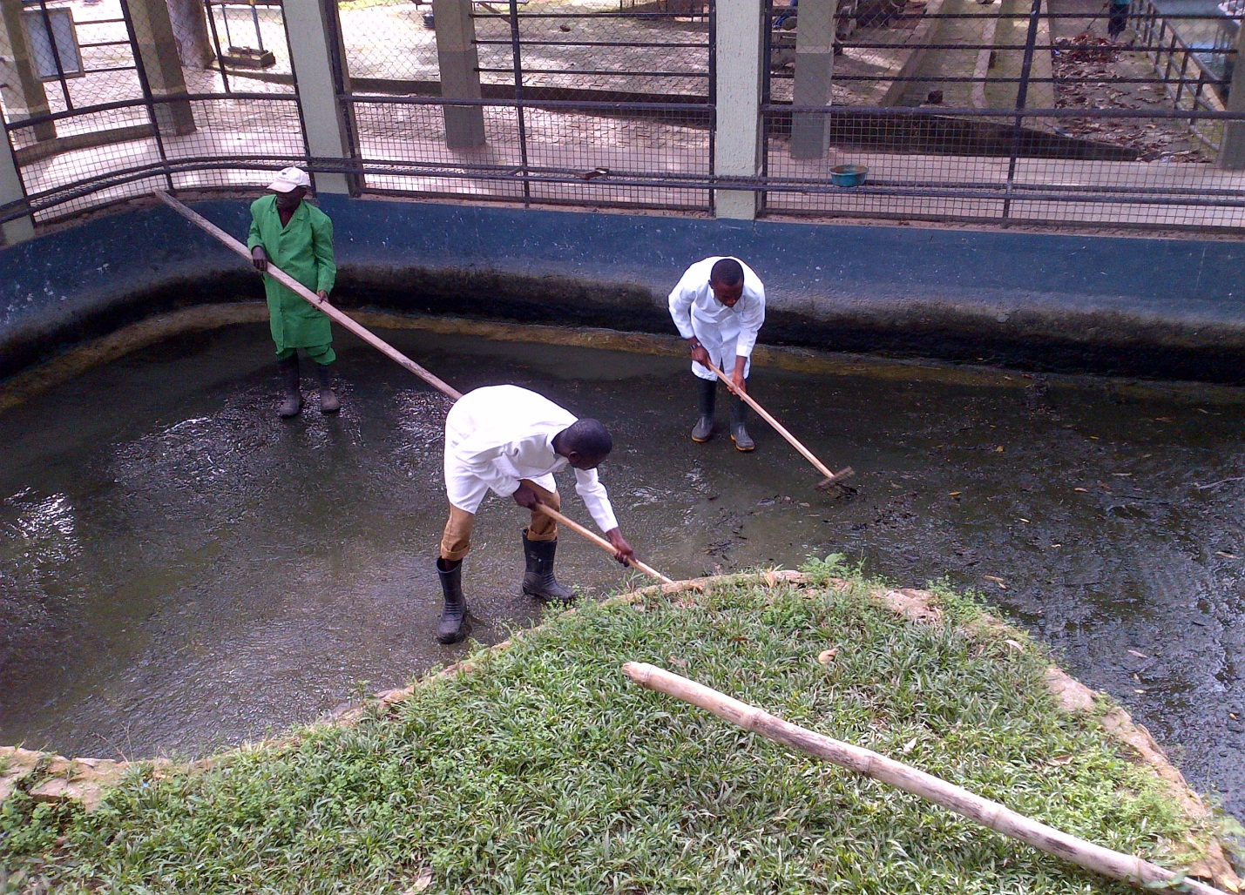
Plate 11: A picture of myself and my colleague together with the supervisor in-charge of the reptile section washing the crocodiles’ moat

CHAPTER THREE
3.0 Canivore section
Carnivores are animals that feed mainly on flesh. At the university of Ibadan zoological garden, there are five species of carnivorous. They include:
TABLE 5: CANIVORES
S/N | Common Name | Binomial Name | Number in the zoo
1 | Lion | Panthera leo | 5
2 | Spotted Hyena | Crocuta crocuta | 1
3 | Stripped Hyena | Hyaena hyaena | 2
4 | Honey Badger | Mellivora capensis | 2
5 | Common Jackal | Canis aureus | 5

3.1 Lion
Scientific classification
Kingdom: Animalia
Phylum: Chordata
Class: Mammalia
Order: Canivora
Family: Felidae
Genus: Panthera
Species: Panthera leo
Conservation status: Vulnerable

Description: Lion is the second largest cat after the tiger. It weighs approximately 250- 270kg. However there are some exceptions as some lions can weigh more. The colour of its skin is light brown. They have strong bodies and powerful forelegs, teeth and jaws for pulling down and killing prey. The nature of its claws is retractable, its claws springs out when it wants to tear its prey. The male is distinguished from the female by the presence of the mane, as the lion grows older its mane becomes thicker. The female is also distinguished by the presence of spots seen on the lower part of its abdomen and on the legs though as she approaches adulthood it grows faint. Lions usually have a large head with a small waist. They have a very fierce look as one cannot determine when they are happy or sad. They roar when they are being disturbed. At the university of Ibadan zoological garden, visitors tend to shout or do something to get the lion attention and as a way of responding, the lion roars. The lion spends between 18-20 hours sleeping.

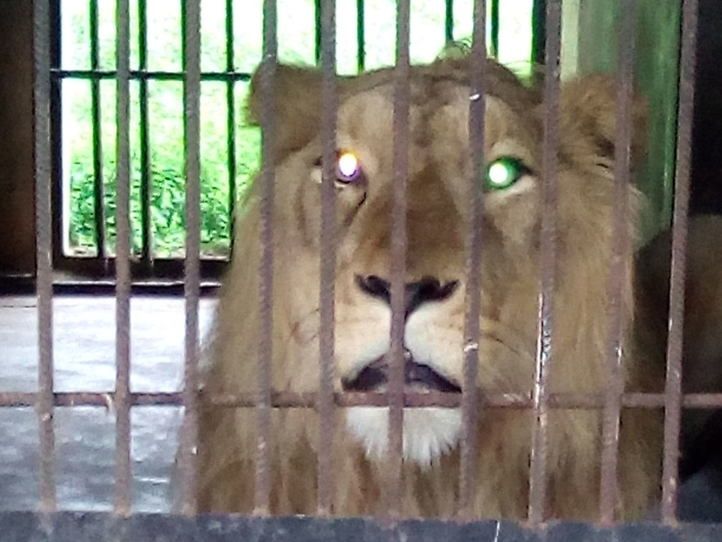
Plate 12: Picture of a lion showing its mane at the U.I zoo

Feeding: At the university of Ibadan zoological garden, the lions are fed thrice a week i.e Mondays, Wednesdays and Fridays. Each of the days eleven goats are usually killed, however there are some days were nine goats were killed and sometimes a cow is usually slaughtered for the canivores. Each time the goat or cow is killed, the internal part of the goat i.e liver, kidney, lungs and intestine is removed and given to other animals that feed on flesh. Then the lions eat the body of the goat or cow, the meat is shared amongst the canivores. There is also a water bowl where drinking water is kept for each of the lion.
Housing structure: At the university of ibadan zoological garden, the den of the lion is built of concerete, strong iron bars for protection, barb wire, wire mesh and aluminium zinc for the roof. Inside the enclosure of each of the lions there is a strong metal door that works by a push and pull rod. This is used when we want to transfer the animal to another enclosure for the purpose of sweeping. There is also a very large grassland that also contains some trees for shade and also some logs of wood used to enrich the environment. The lion and lioness sometimes are released outside to play, exercise their legs, for exhibition, research and also for the purpose of mating. However there are two lions and three lionesses, the two lions are not kept in the same place. The enclosure of the bigger lion called “Arnold” is built seperately and the enclosure of the other lion popularly known as “Isaac” is built with three lionesses and usually it is isaac that is always allowed to the field together with either of the lionesses. Usually in the wild the males guard their territory and any other male that tries to enter the territory, usually results into serious fight. The males were kept seperately to avoid any form of fights. The field is fenced with very high wire mesh that is closely knitted and it also has barb wire at the top of the wire mesh.
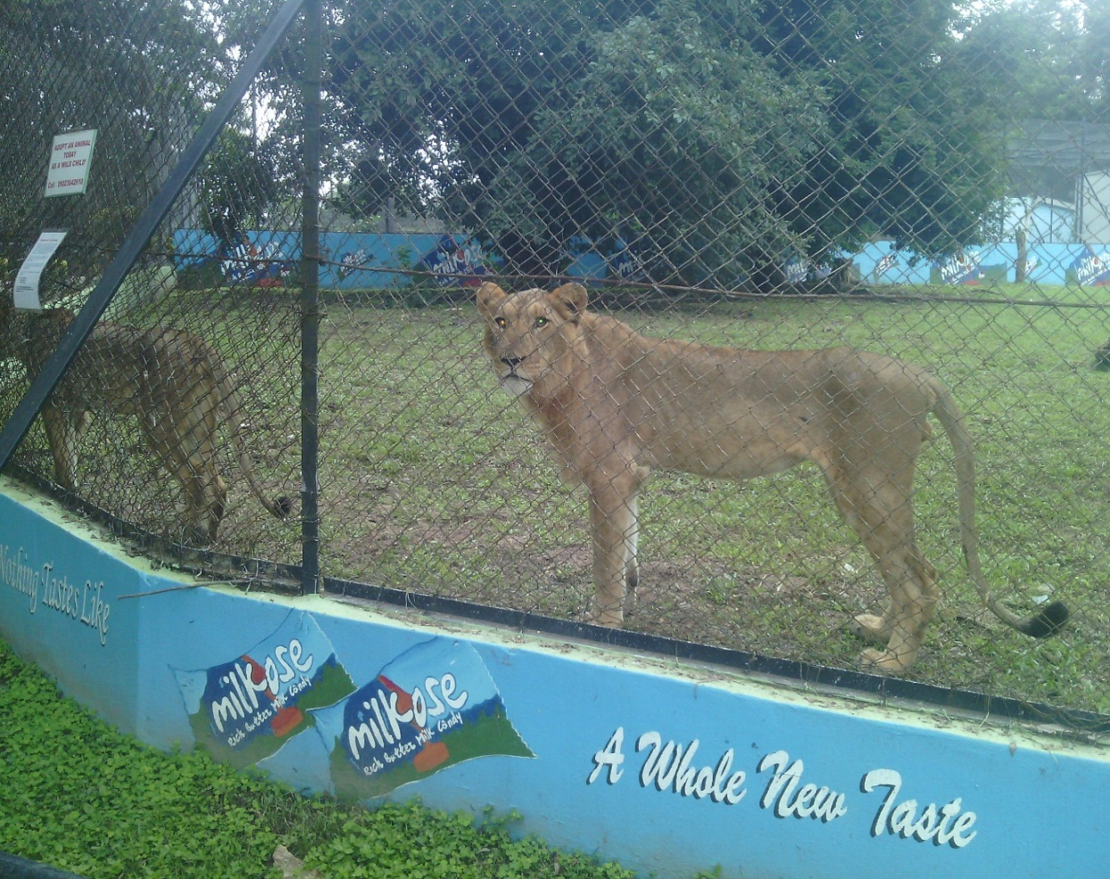
Plate 13: Picture of Isaac and one of the lioness known as Jato in the field however Isaac is by the side.

Behaviour: During my stay in this section, I discovered the lions spend most of the day resting and sleeping, apart from the fact that they are housed in a zoo and visitors usually come to the zoo and people usually are fond of the lion so they tend to shout or mimick its roar just to get its attention, sometimes I take school pupils on tour in the zoo and when we get to the lion’s section the pupils are fond of shouting and this causes the lions to roar heavily. However it is a known fact that the lion can spend 20 hours sleeping in the hours.
Lions can ferocious at times when feeding. In the grassland at the university of Ibadan zoological garden where the lions are released to play, they show affection for each other. I also observed that whenever they see the goats that are going to be slaughtered they tend to be restless because they know it is time for their feeding.
Life span: They can live up to 20-22 years in captivity and in the wild they live up to 14 years the reason they have a shorter life span is that they engage in fight for territory, hunting for food and these cause them to sustain injuries thereby reducing their life span.
3.2 Spotted hyena
Scientific classification
Kingdom: Animalia
Phylum: Chordata
Class: Mammalia
Order: Carnivora
Family: Hyaenidae
Genus: Crocuta
Species: Crocuta crocuta
The spotted hyena (Crocuta crocuta), also known as the laughing hyena, is a species of hyena, currently classed as the sole member of the genus Crocuta, native to Sub-Saharan Africa. The spotted hyena is the largest known member of the Hyaenidae, and is further physically distinguished from other species by its vaguely bear-like build, its rounded ears, its less prominent mane, its spotted pelt, its more dual purposed dentition, its fewer nipples and the presence of a pseudo-penis in the female. It is the only mammalian species to lack an external vaginal opening.
The spotted hyena is the most social of the Carnivora in that it has the largest group sizes and most complex social behaviours. Its social organisation is unlike that of any other carnivore, bearing closer resemblance to that of cercopithecine primates (baboons and macaques) with respect to group-size, hierarchical structure, and frequency of social interaction among both kin and unrelated group-mates. However, the social system of the spotted hyena is openly competitive rather than cooperative, with access to kills, mating opportunities and the time of dispersal for males depending on the ability to dominate other clan-members. Females provide only for their own cubs rather than assist each other, and males display no paternal care. Spotted hyena society is matriarchal; females are larger than males, and dominate them.
Description: The spotted hyena has a strong and well developed neck and forequarters, but relatively underdeveloped hindquarters. The rump is rounded rather than angular, which prevents attackers coming from behind from getting a firm grip on it. The head is wide and flat with a blunt muzzle and broad rhinarium. The ears of the spotted hyena are rounded. Each foot has four digits, which are webbed and armed with short, stout and blunt claws. The paw-pads are broad and very flat, with the whole undersurface of the foot around them being naked. The tail is relatively short. Unusually among hyaenids, and mammals in general, the female spotted hyena is considerably larger than the male. Both sexes have a pair of anal glands which open into the rectum just inside the anal opening. These glands produce a white, creamy secretion which is pasted onto grass stalks by everting the rectum. The odour of this secretion is very strong, smelling of boiling cheap soap or burning, and can be detected by humans several metres downwind. The spotted hyena has a proportionately large heart, constituting close to 1% of its body weight, thus giving it great endurance in long chases. In contrast, a lion's heart makes up only 0.45–0.57 percent of its body weight.
Its fur colour varies greatly and changes with age. Spotted hyena consists of spots, lacking the well-defined spinal mane. The base colour generally is a pale greyish-brown or yellowish-grey on which an irregular pattern of roundish spots is superimposed on the back and hind quarters. The spots, which are of variable distinction, may be reddish, deep brown or almost blackish. The spots vary in size, even on single individuals, but are commonly 20 mm (0.79 in) in diameter. A less distinct spot pattern is present on the legs and belly but not on the throat and chest.

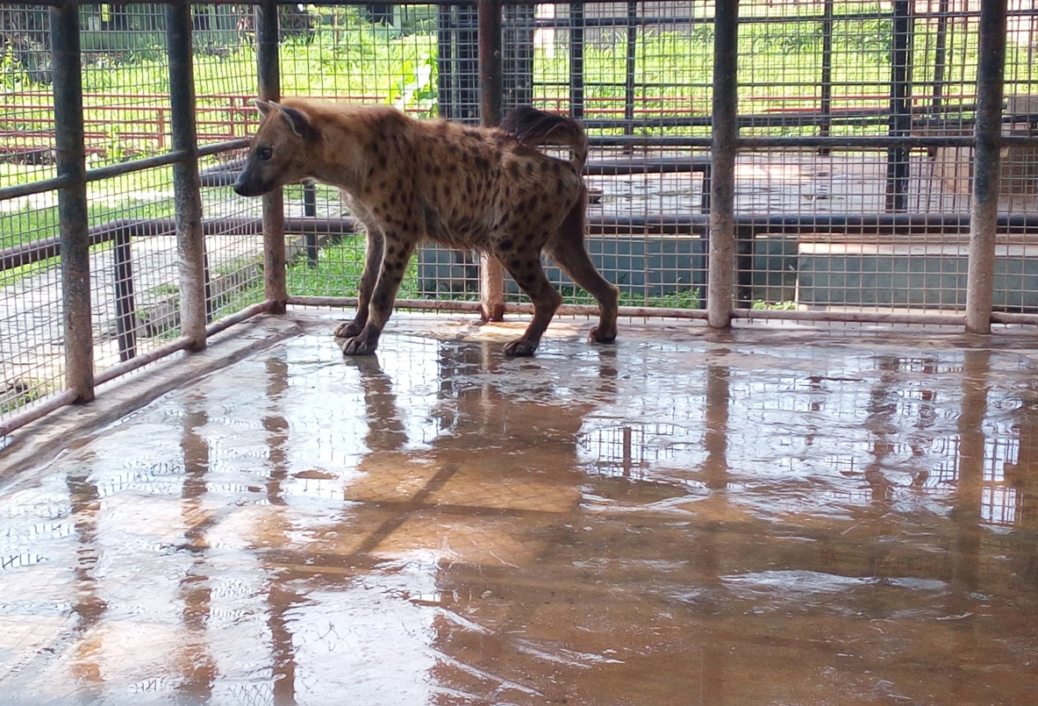
Plate 14: Picture of spotted hyena at U.I zoo.

Feeding: As the norm in the university of Ibadan zoological garden, carnivorous animals are fed thrice in a week. The spotted hyena falls into this category and is fed Mondays, Wednesdays and Fridays. During my training, the spotted hyena feeds on a freshly killed goat and sometimes on parts of a cow if it happens that it was a cow that was killed. The spotted hyena feeds very fast as it takes about 8 minutes to finish its food. They devour every part of their food apart from the fur of their prey. Unlike the lions, when sweeping the enclosure of the spotted hyena, I do not find anything to show that they fed. The only evidence is their feaces, unlike the lion when I sweep its den I sometimes find some pieces of bones they were not able to finish , for the spotted hyena it is not so, as its teeth is specially designed for grinding bones.
Housing structure: The enclosure of the spotted has two sections. One is the enclosures in an open area where the hyena is usually transferred to during the day, as visitors usually come for sightseeing. This floor of the open area is cemented and it is protected with thick and strong wire mesh and its roof is covered with aluminium zinc for protection against harsh weather conditions. The other section is like an inner chamber, its floor is also cemented but the building is made of blocks, there is an iron door connecting to the inner den and near the door is a rod that works by a push and pull system used for transferring the hyena into the open area and back into the inner den. This transfer is done at night and when either of the enclosures is to be swept.
Behaviour: The spotted hyena is basically a predator and not a scavenger. During my training I observed that it does not like mess its enclosure with feaces, it has a particular place where it drops it feaces, though it urinates anywhere and its urine has a very pungent smell. I also observed during my training that when the tail is held up and forward over the back it is excited and it does this on sighting its food. It sometimes laughs as it is popularly known as the” laughing hyena”.
Life span: They can live up to 15 years and even more in captivity.

3.3 Stripped hyena
Scientific Classification
Kingdom: Animalia
Phylum: Chordata
Class: Mammalia
Order: Carnivora
Family: Hyaenidae
Genus: Hyaena
Species: Hyaena hyaena
Conservation status: Near threatened
The striped hyena (Hyaena hyaena) is a species of hyaena native to North and East Africa, the Middle East, the Caucasus, Central Asia and the Indian subcontinent.
It is the smallest of the true hyenas and retains many primitive viverrid characteristics lost in larger species, having a smaller and less specialised skull. Though primarily a scavenger, large specimens have been known to kill their own prey, and attacks on humans have occurred on rare instances. The striped hyena is a monogamous animal, with both males and females assisting one another in raising their cubs. A nocturnal animal, the striped hyena typically only emerges in complete darkness, and is quick to return to its lair before sunrise. Although it has a habit of feigning death when attacked, it has been known to stand its ground against larger predators in disputes over food.
Description: The stripped hyena has mane that runs from the head through the spine down to its tail. The colour of its skin includes stripes of black and brown. The stripes of black are seen around the leg and its stomach. The striped hyena has a fairly massive, but short torso set on long legs. The hind legs are significantly shorter than the forelimbs, thus causing the back to slope downwards. The legs are relatively thin and weak, with the forelegs being bent at the carpal region. The neck is thick, long and largely immobile, while the head is heavy and massive with a shortened facial region. The eyes are small, while the sharply pointed ears are very large, broad and set high on the head. Like all hyenas, the striped hyena has bulky pads on its paws, as well as blunt but powerful claws. The tail is short and the terminal hairs do not descend below the achilles tendon. The striped hyena lacks the enlarged clitoris and false scrotal sack noted in the female genitalia of the spotted hyena. The female has 3 pairs of nipples. Adult weight can range from 22 to 55 kg, averaging at about 35 kg. The anus can be everted up to a length of 5 cm, and is everted during social interaction and mating. When attacked, the striped hyena everts its rectum and sprays a pungent smelling liquid from its anal glands. Its eyesight is acute, though its senses of smell and hearing are weak.
Feeding: During my training they were fed three times a week just like all other carnivorous. They feed on freshly killed goat and sometimes when there is cow for the carnivores, they feed on the leg, hand and other parts.
Housing structure: The enclosure of the stripped hyena is similar to that of the spotted hyena. The only difference is that here there two inner enclosures apart from the open area where they are released to play and for visitors coming into the zoo to have a good view of the animals. The floor of both the inner enclosure and open area is cemented, the open area is surrounded with thick and strong wire mesh and the inner is built with blocks, the roof of the inner is covered with aluminium zinc. The open area has no covering. They transferred into the inner enclosure at night, when their enclsoure is being swept and when the weather is very cold as a result of heavy rainfall.
Behaviour: The striped hyena is a primarily nocturnal animal, which typically only leaves its den at the onset of total darkness, returning before sunrise. They are generally not territorial animals, with home ranges of different groups often overlapping each other. When marking their territory, striped hyenas use the paste of their anal pouch (hyena butter) to scent mark grass, stalks, stones, tree trunks and other objects. In aggressive encounters, the black patch near the thoracic and lumbar vertebrae is erected. When fighting, striped hyenas will bite at the throat and legs, but avoid the mane, which serves as a signalling device. When greeting each other, they lick the mid-back region, sniff each other's noses, extrude their anal pouch or paw each other's throats. The species is not as vocal as the spotted hyena, its vocalisations being limited to a chattering laugh and howling.
Burrowing behaviours in the wild
The striped hyena may dig its own dens, but it also establishes its lairs in caves, rock fissures, erosion channels and burrows formerly occupied by porcupines, wolves, warthogs and aardvarks. Hyena dens can be identified by the presence of bones at their entrances. The striped hyena hides in caves, niches, pits, dense thickets, reeds and plume grass during the day to shelter from predators, heat or winter cold.
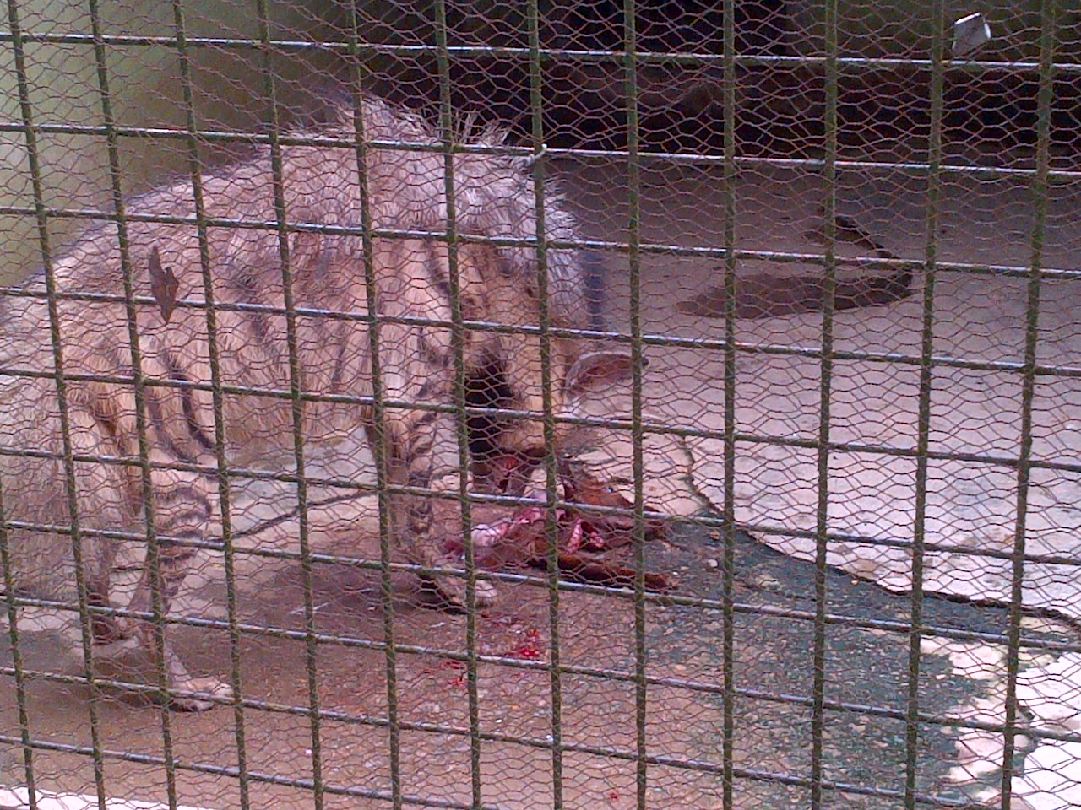
Plate 15: Picture of stripped hyena feeding on a goat at U.I zoo

3.4 General sanitation done in the carnivore section
During my training in this section, I was taught that one of the basic qualities needed in working in this section is extreme carefulness as carnivorous are known to feed basically on flesh. Before we even proceed to washing and cleaning the enclosure of any of the carnivorous animal, First we transfer the animal into another empty enclosure and this is done by the push and pull system using the iron rod and after the animal has been transferred into the new enclosure, we then lock the enclosure and the rod that works by the push and pull system because the rod is designed in a way that it has a padlock as it controls a metal slide door that seperates the animal from both enclosures. As part of my duty in this section the following was done by me, other industrial training students and the zoo keepers in charge of the section whom I worked with:
- Sweeping and washing the enclosure of the animals daily.
- Removing the feaces of the animals while sweeping.
- Washing the drinking bowl of the animals daily.
- Removing cob webs in and around the enclosures.
- Trimming of the grasses in the open field where the lions are usually released to play and mate. This usually done by some people who work in the university zoo.
- Once in two weeks the enclosure of all the carnivorous animals is washed with chlorine to remove any form of dirts and to prevent the animal from being exposed to any form of disease.
- While we wash the enclosure of the animal, we use Izal to reduce the pungent odour of their enclosure as the feaces and urine of these carnivorous animals has very strong bad odour.
3.5 Food quantity given to the canivores
Oldest lion – 2 Goats
Adult lion and lioness- 1^{1/2} goats each
Hyena (spotted and stripped)- 1^{1/2} goats each
Jackals- leg of the goat each
Honey badger- pieces of the goat meat given to each .
3.6 Medications given to the canivores
The carnivorous animals are dewormed once in three months. They are usually dewormed with pipera vet dewormer. However prescription of the deworming is done by the veterinary doctors working with the zoo. The dosage for each of the animal is as follows:
Lion- 200ml, Spotted hyena- 100ml, Stripped hyena- 50ml, Common jackal- 10ml, Honey badger- 20ml.
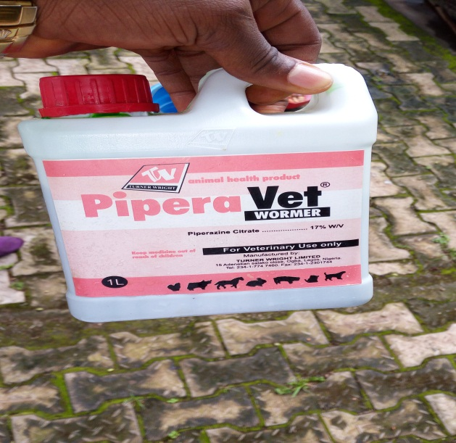
Plate 16: Picture of pipera vet dewormer.

3.7 Omnivore section
Omnivorous animals are animals that feed on both plants and animals. At the university of Ibadan zoological garden, there are six species of omnivores, however some rodents are grouped under this section.
TABLE 6: OMNIVORES
S/N | Common Name | Binomial Name | Number in the zoo
1 | Domestic pig | Sus scrofa | 7
2 | Grass cutter | Thryonomys swinderianus | 3
3 | Guinea pig | Cavia porcellus | 2
4 | Crested Porcupine | Hystrix cristata | 2
5 | Warthog | Phacochoerus africanus | 1
6 | Giant rat | Cricetomys ansorgei

3.7.1 Warthog
Scientific classification
Kingdom: Animalia
Phylum: Chordata
Class: Mammalia
Order: Artiodactyla
Family: Suidae
Genus: Phacochoerus
Species: Phacochoerus africanus
Conservation status: least concern
The common warthog (Phacochoerus africanus) is a wild member of the pig family (Suidae) found in grassland, savanna, and woodland in sub-Saharan Africa.
Description: The warthog is sometimes referred to as the wild pig. It has two pairs of tusks protruding from the mouth and curving upwards. The lower pair is shorter than the upper pair. Its head is large with a scanty mane that runs through the spine. The colour of its body is brown and it is sparsely haired. Warthogs do not have subcutaneous fat and the coat is sparse, making them susceptible to extreme environmental temperatures.
Housing structure: At the university of Ibadan zoological garden, the warthog is housed in a relatively large area that is water-logged and muddy. This done intentional as it allows the warthog to wallow in the mud especially during sunny afternoons as way of coping with the hot temperature. There is also an enclosure that is fenced with aluminium zinc surrounded by with thick wire mesh, the warthog goes here at times when it wants to sleep. A pavement is also built near the water logged moat, here the animal’s food is kept here and there is also a water trough where drinking water is kept for the animal.
Feeding: During my training in this section, the warthog feeds on water grass, it also feeds on guinea corn (red and white) and it usually given the head of cat fish to feed on. It feeds daily.
Behaviour: During my training in this section, I observed the animal to be very aggressive. If anyone comes around its cage and tries to do to get its attention, it responds by coming aggressively in a bid to attack. I also discovered that it wallows in the mud as a way of cooling its body temperature.
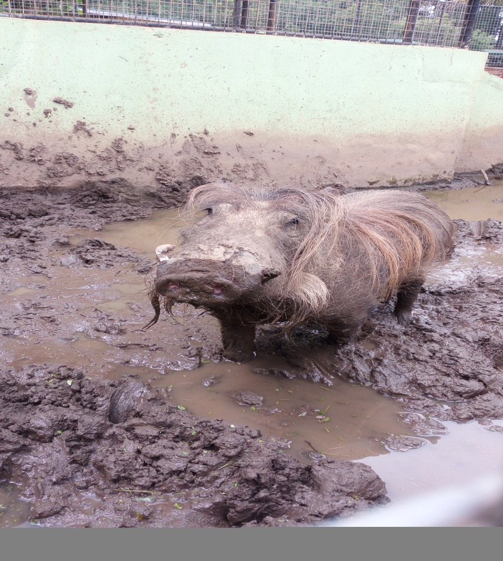
Plate 17: Picture of the warthog at U.I zoo.

Life span: In the wild, it can live between 12-15 years while in captivity, it can live up to 18-22 years.
Sanitation done at the Warthog’s enclosure
The following was done by me at the warthog’s enclosure:
- Sweeping of its pavement
- Packing out water out of its enclosure when over-logged with water
- Sweeping and cleaning of its enclosure.
However when the sanitation is being done the animal is usually locked in its enclosure.

3.7.2 Crested porcupine
Scientific Classification
Kingdom: Animalia
Phylum: Chordata
Class: Mammalia
Order: Rodentia
Family: Hystricidae
Genus: Hystrix
Species: Hystrix cristata
Description: The adult crested porcupine has an average head and body length of about 60 to 83 cm long, discounting the tail, and weighs from 13 to 27 kg.
Almost the entire body is covered with bristles which are white and black mixed together. This mammal is recognizable by the quills that run along the head, nape, and back that can be raised into a crest. There are also some sturdier quills which run along the sides and back half of the body. These sturdier quills are used, for defense and are usually marked with light and dark bands which alternate; these are not firmly attached. This porcupine has a shorter tail which has rattle quills at the end. The rattle quills broaden at the terminal end and the broad portion is hollow with thin walls. When these quills are vibrated they produce a hiss-like rattle.
The front feet of the crested porcupine have four developed and clawed digits with a regressed thumb, the rear feet have five. The paws have naked and padded soles and have a plantigrade gait. The ears are external and both the eyes and ears are very small with long vibrissae on its head.
Housing structure: The enclosure of the porcupine at the university of Ibadan zoological garden is designed such that it is home friendly. The floor of its enclosure is not cemented, there two round cemented bricks made of gravel designed for the animals to go in and rest because there are two porcupines at the university of Ibadan zoological garden. The enclosure is surrounded with wire mesh that is closely fitted to serve as protection for the animal. Its roof is covered with aluminium zinc. There is also a water bowl where drinking water is usually put for them.
Feeding: During my training I fed the porcupines with yam mixed palm oil and sometimes I fed them with beans. They are usually fed daily.
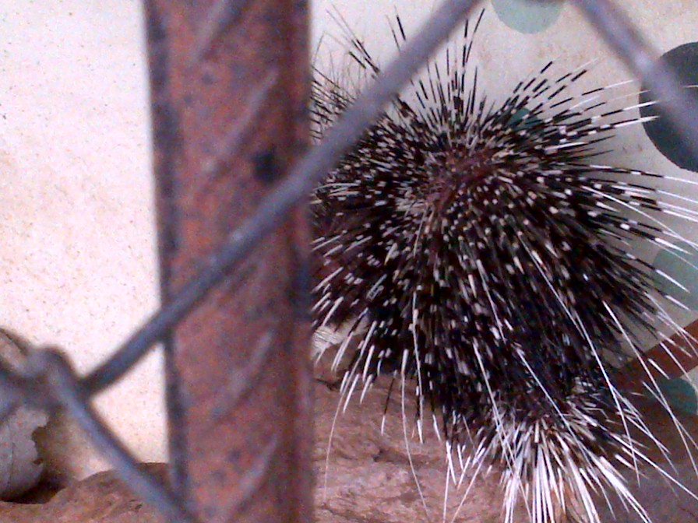
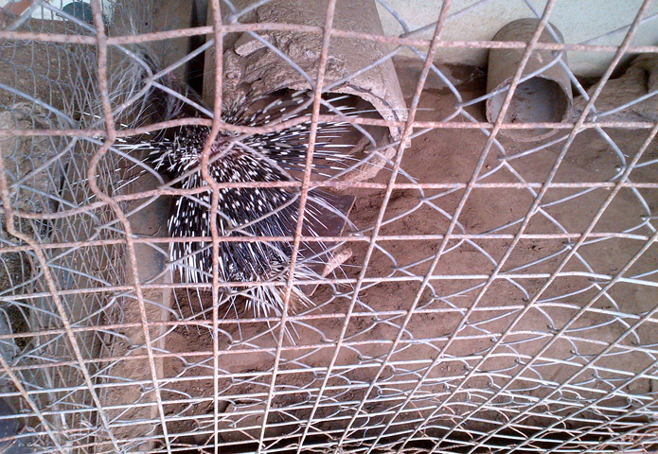
Plate 18: Picture of the porcupine showing its quills.
Plate 19: Picture of the bigger porcupine trying to enter the round hole at U.I zoo

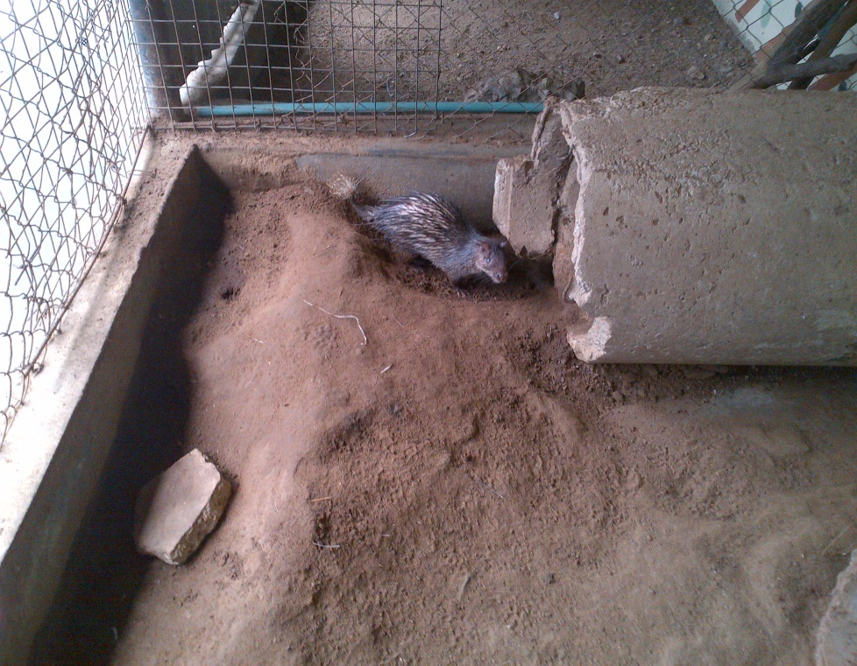
Plate 20: Picture of the smaller porcupine at U.I zoo.

Behaviour of the crested porcupine in the wild: The crested porcupine is a terrestrial mammal; they very seldom climb trees, but can swim. They are nocturnal and monogamous. The crested porcupine takes care of the young for a long time and small family groups consist of the adult pair and young of various ages. In defense, when disturbed, they raise and fan their quills to make themselves look bigger. If continually bothered, the crested porcupine will stamp its feet, whirr the quills, and charge the disturber back end first trying to stab the enemy with the thicker, shorter quills. These attacks are known to have killed lions, leopards, hyenas, and even humans.
Sanitation done at the crested porcupine’s enclosure
- I sweep its enclosure daily.
- I change the drinking in its bowl daily.
3.7.3 Treatment of ominivores
Usually adequate care is been given to the animals as the case occurred when one of the porcupine (the bigger one) had an injury the animal was treated and where the injury was visible it was sprayed with oxytetravet aerosol. And after some time the injury healed.
Deworming for the omnivore is done every three months and during my industrial training in the zoo, the drug used in deworming was Levamisole. The drugs were administered to the animals by mixing the food with the drug.
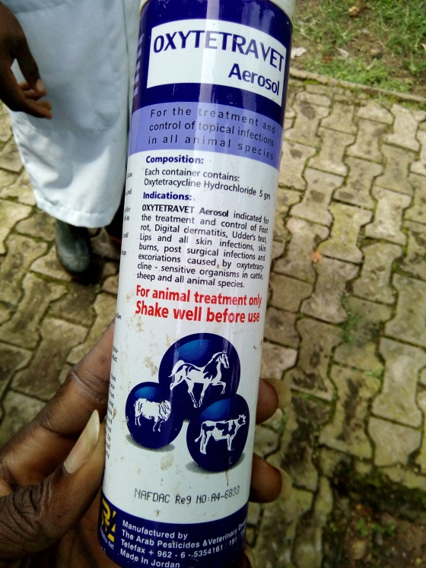
Plate 21: Picture of the spray Oxytetravet Aerosol used in spraying the injury area of the crested porcupine.

CHAPTER FOUR
4.0 Herbivore section
Herbivores are animals that basically feed on plants. At the university of Ibadan zoological there are there seven species of herbivores and they are shown in the table below.
TABLE 7: HERBIVORES
S/N | Common Name | Binomial Name | Number in the zoo
1 | Camel | Camelus dromedaries | 1
2 | Dorcas Gazzelle | Gazellae dorcas | 2
3 | Giant Eland | Taurotragus derbianus | 2
4 | Horse | Equs ferus | 6
5 | Maxwell’s Duiker | Philantomba maxwelli | 3
6 | Giraffe | Giraffa camelopardalis | 1`
7 | Donkey | Equs africanus | 3

4.1 Giant eland
Scientific Classification
Kingdom: Animalia
Phylum: Chordata
Class: Mammalia
Order: Artiodactyla
Family: Bovidae
Genus: Taurotragus
Species: Taurotragus derbianus
The giant eland (Taurotragus derbianus), also known as the Lord Derby eland, is an open-forest and savanna antelope. The giant eland is the largest species of antelope in the world. The giant eland is an herbivore, eating grasses, foliage and branches. They usually form small herds consisting of 15–25 members, both males and females. Giant elands are not territorial, and have large home ranges. They can run at up to 70 km/h (43 mph) and use this speed as defence against predators. Mating occurs throughout the year but peaks in the wet season. They mostly inhabit broad-leafed savannas, woodlands and glades.
Description: The giant elands are spiral-horned antelopes. They are typically between 220 and 290 cm (7.2 and 9.5 ft) in head-and-body length and stand approximately 130 to 180 cm (4.3 to 5.9 ft) at the shoulder. Giant elands exhibit sexual dimorphism, as males are larger than females. The males weigh 400 to 1,000 kg and females weigh 300 to 600 kg. The tail is long, having a dark tuft of hair.
The smooth coat is reddish-brown to chestnut, usually darker in males than females, with 8–12 well-defined vertical white stripes on the torso. The colour of the male's coat darkens with age. A crest of short black hair extends down the neck to the middle of the back, and is particularly prominent on the shoulders. The slender legs are slightly lighter on their inner surfaces, with black and white markings just above the hooves. There are large black spots on the upper forelegs. The bridge of the nose is charcoal black, and there is a thin, indistinct tan-coloured line, which is the chevron, between the eyes. The lips are white, as are several dots along the jawline. A pendulous dewlap, larger in males than females, originates from between the jowls and hangs to the upper chest when they reach sexual maturity, with a fringe of hair on its edge. The large ears of the giant eland serve as signaling devices
Both sexes have tightly spiraled, 'V'-shaped horns. They can be up to 123 cm (4.04 ft) long on males and 66 cm (2.17 ft) on females. Males have horns that are thicker at the ends, longer, and more divergent than those of females.

Housing structure: The enclosure for the giant eland at the university of Ibadan zoological garden, is very large. There is vast land where the animals can exercise themselves and also graze. There also a building in its enclosure where the animals go to rest and sleep at night. In the building there is a constructed water trough where water is put for the animals, there is also a space where their food is also kept for each of them as there are two giant elands in U.I zoo. The enclosure is protected with thick wire mesh for protection as it also serve as a demarcation between them and the dorcas gazelle and Maxwell duiker at the left because the dorca gazelle and Maxwell’s duiker are housed in the same place and also a demarcation between the giant eland and the horse at the right. The enclosure has grasses in it as this is used to enrich its environment.
Feeding: During my training in this section, I fed the giant eland with compounded feed, a special feed that has a mixture of maize, guinea corn (red and white), sorghum, millet and also plantain is cut in small bits and mixed in the compounded feed. I also cut water grass for them in the zoo and give them, the water grass are given in large proportion compared to the compounded feed. During my training, at one point all the herbivore were given calcuim and I was told it helps them develop strong bones

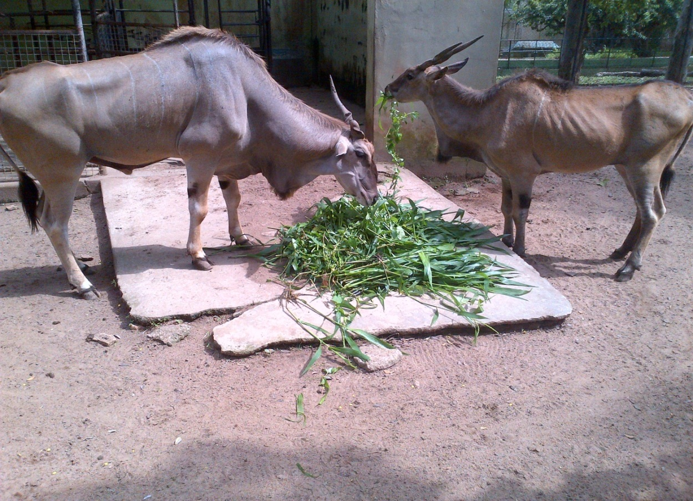
Plate 22: Picture of the giant elands feeding on a mixture of water grass and acacia.
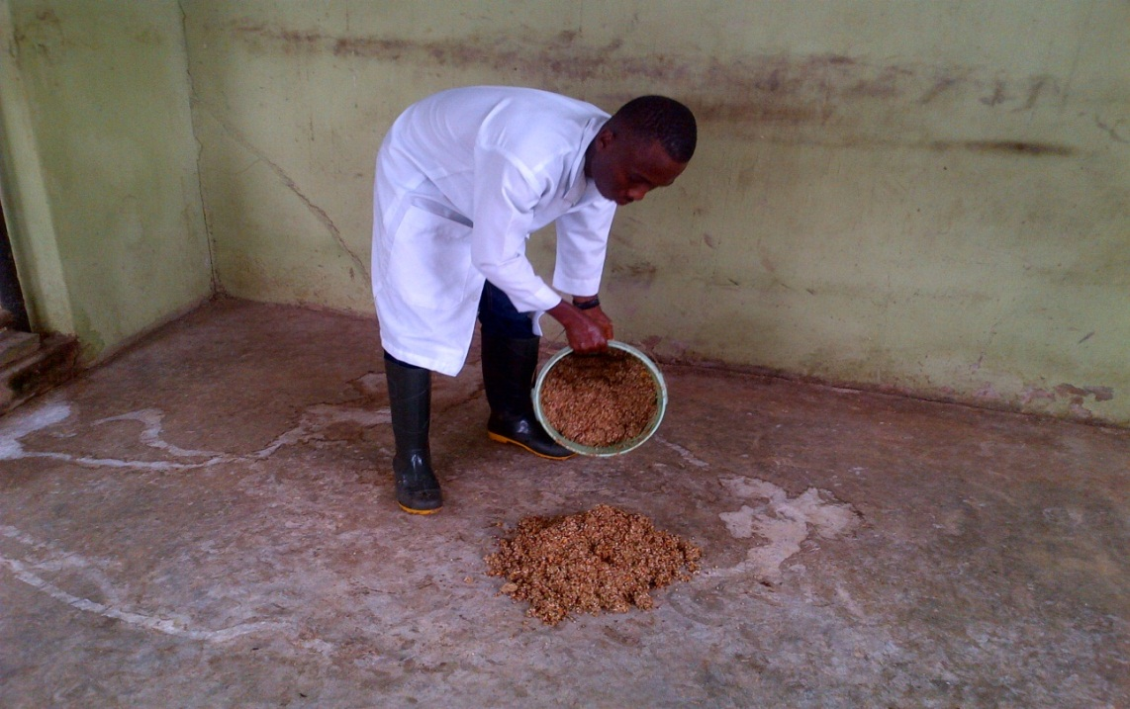
Plate 23: Picture of me pouring the compounded feed for the giant eland to feed.

Behaviour: They are naturally alert and wary, which makes them difficult to approach and observe. In the wild, If a bull senses danger, he will give deep-throated barks while leaving the herd, repeating the process until the whole herd is aware of the danger. Giant elands can move quickly, running at over 70 km/h (43 mph), and despite their size are exceptional jumpers, easily clearing heights of 1.5 m (4.9 ft).Their primary predators are the lion and spotted hyena, while young, sickly and a rare adult may be vulnerable to leopards and African wild dogs. Due to their large size, they prove a good meal for the predators. However, they are not easily taken by any predator, especially the heavier and larger horned bulls which can be a dangerous adversary even for a lion pride.

4.2 Horse
Scientific classification
Kingdom: Animalia
Phylum: Chordata
Class: Mammalia
Order: Perissodactyla
Family: Equidae
Genus: Equus
Species: Equus ferus
Description: They are odd toe ungulate mammasl. Horses' anatomy enables them to make use of speed to escape predators and they have a well-developed sense of balance and a strong fight-or-flight response. Related to this need to flee from predators in the wild is an unusual trait: horses are able to sleep both standing up and lying down. Female horses, called mares, carry their young for approximately 11 months, and a young horse, called a foal, can stand and run shortly following birth. At the university if Ibadan zoological garden, their colour ranges from pure brown to black to brownish black.
Housing structure: The housing structure of the horses at the university of Ibadan zoological garden is large. There are 3 different placed in the zoological garden where these horses are housed. One of the horses is housed in a relatively large grassland, this horse has access to the grasses and therefore it feeds by itself. Another of the horses are housed in an enclosure close to the giant eland, here there is building made for the three horses housed here to rest. We supply this ones grasses as they do not have access to the grasses themselves because they are enclosed. The last two ones are housed in a separate enclosure and their housing structure is the same with previous ones.
The floor of the horses housed in an enclosure are not cemented, their enclosure is surrounded with thick wire mesh and there is also specially built trough were drinking water is put for the animals. The first one that is housed in an open grassland has a bucket were drinking water is put for it and usually there is always a rope used to restrain the horse from roaming about.
Feeding: During my training, I fed the horses with compounded feed a mixture of different feeds that includes yellow maize, bean shaft, wheat and guinea corn grinded together. They feed daily. I also cut elephant grass for to eat.
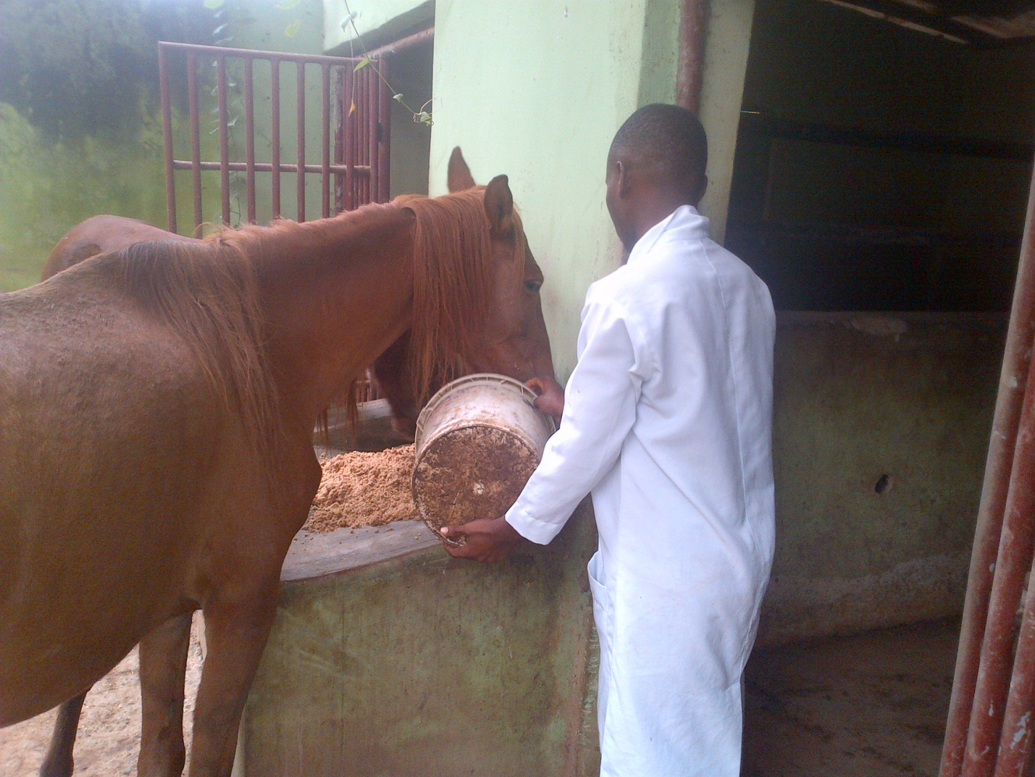
Plate 24: Picture of me pouring the compounded feed for the horses to eat.

Life span: They have an average lifespan of between 25 and 30 years.

4.3 Dromedary camel
Scientific classification
Kingdom: Animalia
Phylum: Chordata
Class: Mammalia
Order: Artiodactyla
Family: Camelidae
Genus: Camelus
Species: Camelus dromedaries
Description: It is an even-toed ungulate within the genus Camelus, bearing distinctive fatty deposits known as "humps" on its back. The dromedary camel has one at its back otherwise known as the one-humped camel. The humps are reservoirs of fatty tissue: concentrating body fat in their humps minimizes the insulating effect, helping camels survive in hot climates. When this tissue is metabolized, it yields more than one gram of water for every gram of fat processed. This fat metabolization, while releasing energy, causes water to evaporate from the lungs during respiration (as oxygen is required for the metabolic process).The colour of its skin is light brown. The male dromedary camel has in its throat an organ called a dulla, a large, inflatable sac he extrudes from his mouth when in rut to assert dominance and attract females. It resembles a long, swollen, pink tongue hanging out of the side of its mouth.
Camels mate by having both male and female sitting on the ground, with the male mounting from behind. The male usually ejaculates three or four times within a single mating session. Camelids are the only ungulates to mate in a sitting position. A full-grown adult camel stands 1.85 m (6 ft 1 in) at the shoulder and 2.15 m (7 ft 1 in) at the hump. Camels can run at up to 65 km/h (40 mph) in short bursts and sustain speeds of up to 40 km/h (25 mph).
Housing structure: The dromedary camel at the university of Ibadan zoological garden is housed in a very spacious grassland. Its enclosure has a building where the camel goes in to rest or when the weather is hot. There are also trees planted around in its enclosure, the camel sometimes when grazing goes under these trees to rest. The enclosure is surrounded by Iron railing round it. In its enclosure there is a bucket where drinking water is put for the animal.
Feeding: During my training, I fed the dromedary camel with compounded feed as explained earlier in the horse section. The camel also feeds on water grass. Its feeds daily.
Life span: The average life expectancy of a camel is 40 to 50 years.
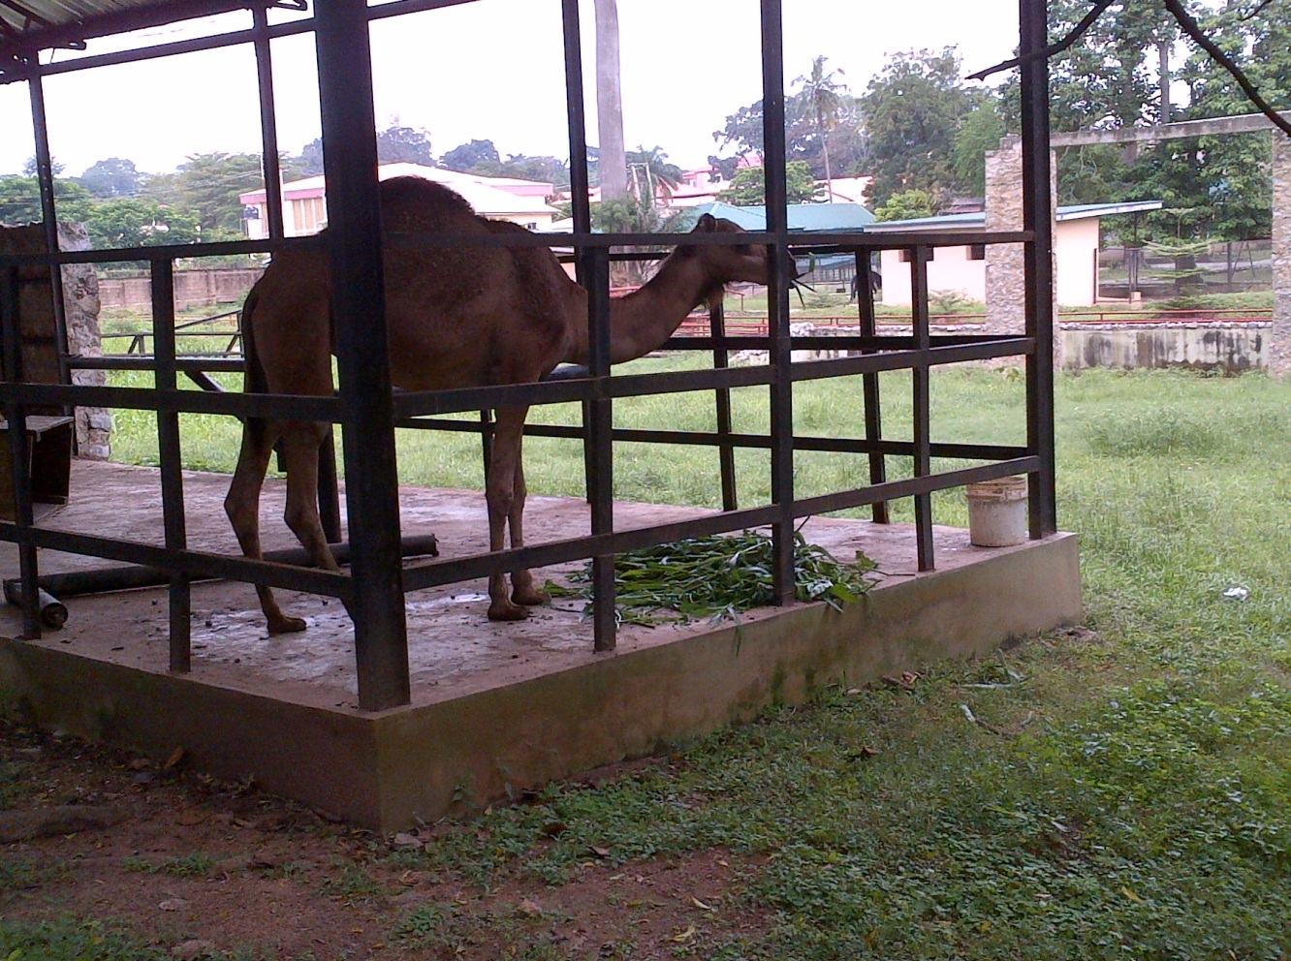
Plate 25: Picture of the camel feeding on water grass at U.I zoo

4.4 General sanitation done in the herbivore section
As a part of my rountine in this section the following was always done by me and other industrial training I was working during my stay in this section and they are:
- Sweeping of the enclosures and the surroundings of the animals in this section.
- Washings of their water troughs daily while sweping.
- Removing of cobwebs around their enclosure regularly.
- Trimming of the grasses especially for those animals whose habitat are grassland e.g Girrafe, Camel, some of the Horses and the dorcas gazelle and Maxwell’s duiker because both live in the same enclosure.
- Removing muddy water in the pen of the horses.

4.5 General care given to the herbivores
As part of the care given to the herbivores the following are done regularly:
- Levamisole is used in deworming them and this is done in a space of three months.
- Salt mould are usually given to the animals as it helps the animal in developing strong bones and hoofs.
- The herbivores are regularly sprayed with ectoparasite powder to help kill and also chase parasites from the body of these animals.
- Biovitamitins, a feed supplement is usually given to the animals to provide them with vitamins they don’t get in their food.
4.6 Primate section
At the university of Ibadan zoological garden, there are eight species of primates. They are housed at different sections called the central monkey and the ape house. Primate housed in the central monkey include Patas monkey, Drill monkey, Collared mangabey, White throated guenon, Mona monkey and the Green monkey. While at the ape house, the priamtes here include Anubis baboon and Chimpanzee.
TABLE 8: PRIMATES
S/N | Common Name | Binomial Name | Number in the zoo
1 | Anubis baboon | Papio Anubis | 5
2 | Chimpanzee | Pan troglodytes | 2
3 | Drill monkey | Cercopithecidae mandrillus | 2
4 | Mona monkey | Cercopithecus mona | 4
5 | Green monkey | Chlorocebus sabaeus | 6
6 | White throated guenon | Cercopithecidae erythrogaster | 1
7 | Collared mangabey | Cercopithecidae cercocebus | 2
8 | Patas monkey | Erythrocebus patas | 5

4.6.1 Mona monkey
Scientific classification
Kingdom: Animalia
Phylum: Chordata
Class: Mammalia
Order: Primates
Family: Cercopithecidae
Genus: Cercopithecus
Species: Cercopithecus mona
Conservation status: Least concern
Description: The mona monkey (Cercopithecus mona) is an Old World monkey that lives throughout western Africa It mainly feeds on fruit, but sometimes eats insects and leaves.
The mona monkey has brown agouti fur with a white rump. Its tail and legs are black and the face is blue-grey with a dark stripe across the face. The mona monkey carries food in cheek pouches.
Housing structure: The enclosure of the mona monkey at the university of Ibadan zoological garden designed in a way that it is suitable for the animal. Its floor is not cemented, it has a lot of iron railings designed at various heights for the animal as it loves to jump and climb. There is specially built trough in its enclosure where drinking water is put the animal. The enclosure is surrounded with wire mesh around it as visitors that come around have a fine view of the animal.
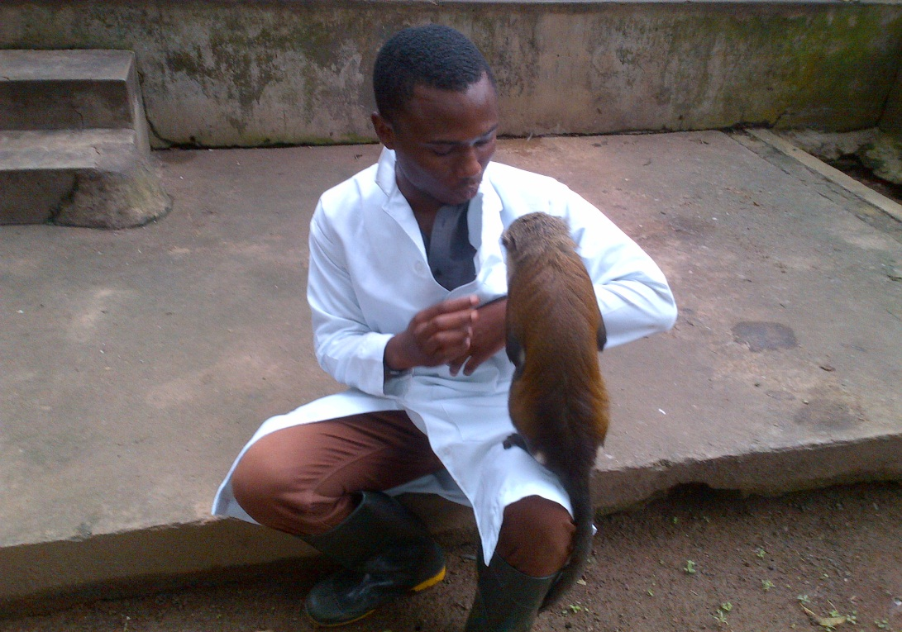
Plate 26: Picture of the mona monkey sitting on my lap in U.I zoo.

Feeding: During my training in this section, I fed the mona monkey with assorted fruits which includes water melon, bananas, pineapples and oranges. It feeds daily. During the aftermoon most animals in the primate section are fed with yam mixed with oil and sometimes beans. There is trough in its enclosure where drinking water is served daily.
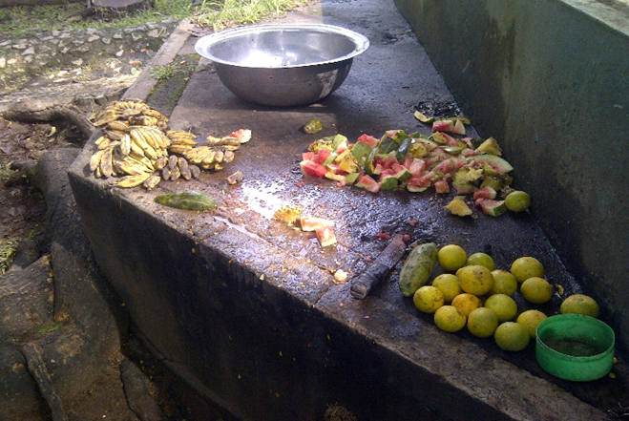
Plate 27:Picture of the some of the fruits to be served to the primates.
Behaviour: I observed my training in this section, that the mona monkey is a very friendly animal once it trust is gained they can be very free and harmless. But if it discovers someone to be uncomfortable with it, it tend to avoid such person.

4.6.2 White throated guenon
Scientific classification
Kingdom: Animalia
Phylum: Chordata
Class: Mammalia
Order: Primates
Family: Cercopithecidae
Genus: Cercopithecus
Species: Cercopithecus erythrogaster
Conservation status: Vulnerable
Description: The white-throated guenon (Cercopithecus erythrogaster), also known as the red-bellied monkey or the red-bellied guenon, is a diurnal primate that lives on trees of rainforests or tropical areas of Nigeria and Benin. The name guenon comes from the French word for fright and refers to the baring of teeth when these monkeys are excited or distressed.
The white-throated guenon is usually a frugivore but insects, leaves, and crops are also in its diet. It is arboreal, living in moist tropical forest and the wettest parts of dry tropical forest, however it can also be found in secondary bush and old farmland. Males weigh from 3.5–4.5 kg and females weigh 2–4 kg. The white-throated guenon is still considered a vulnerable species near extinction due to its decreasing population.

There are two subspecies of white-throated guenon:
- Red-bellied guenon, Cercopithecus erythrogaster erythrogaster.
- Nigerian white-throated guenon, Cercopithecus erythrogaster pococki.
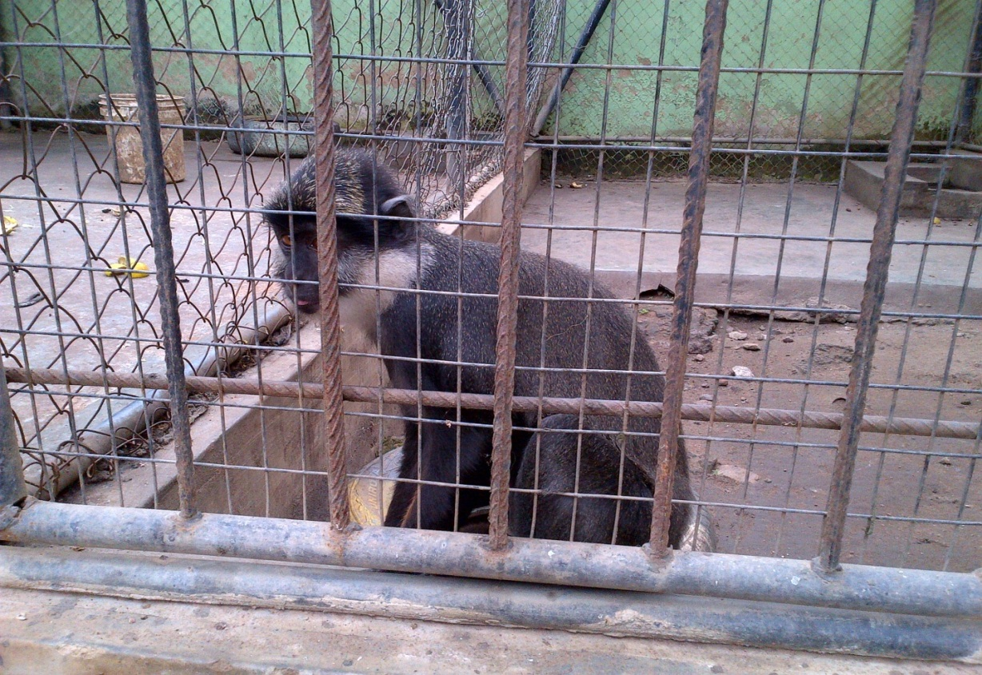
Plate 28:Picture of the white throated guenon at U.I zoo.

Housing structure: Its enclosure at the university of Ibadan zoological garden is surrounded with thick wire mesh. Some part of its floor is cemented while some part is not cemented, there is a trough built in its enclosure where drinking is served for the animal. Its roof is not covered.
Feeding: Generally all the animals in the primate section feeds on fruits. The white throated guenon feeds on assorted fruits which include water melon, bananas and oranges. They are also fed with yam mixed with oil or beans in the afternoons. They fed daily.
Behaviour: During my training in this section, I observed the animal to be a very observant and inquisitive. Sometimes when I sweep its enclosure the animal always watch me and sometimes it even comes to touch my boot and feel it.
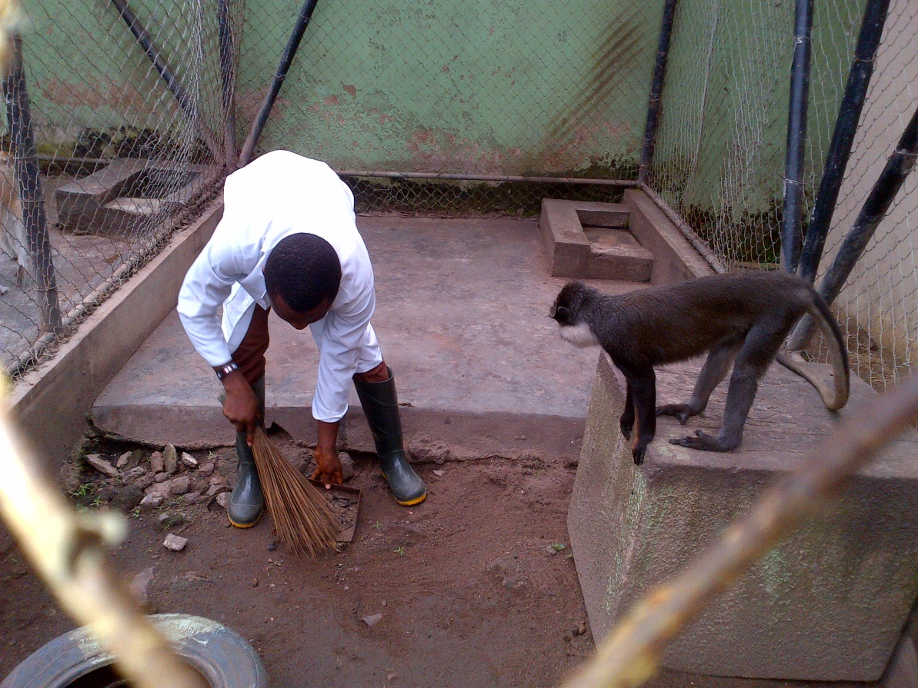
Plate 29: Picture of the white throated guenon watching me while I sweep its enclosure.

4.6.3 Patas monkey
Scientific classification
Kingdom: Animalia
Phylum: Chordata
Class: Mammalia
Order: Primates
Family: Cercopithecidae
Genus: Erythrocebus
Species: Erythrocebus patas
Conservation status: least concern

Description: The patas monkey grows up to 85 cm in length, excluding the tail, which measures 75 cm. Adult males are considerably larger than adult females. It is the fastest runner among the primates reaching speeds of 55 km/h (34 mph). The colour of its skin is light brown and its colour underneath is mixture of white and black.
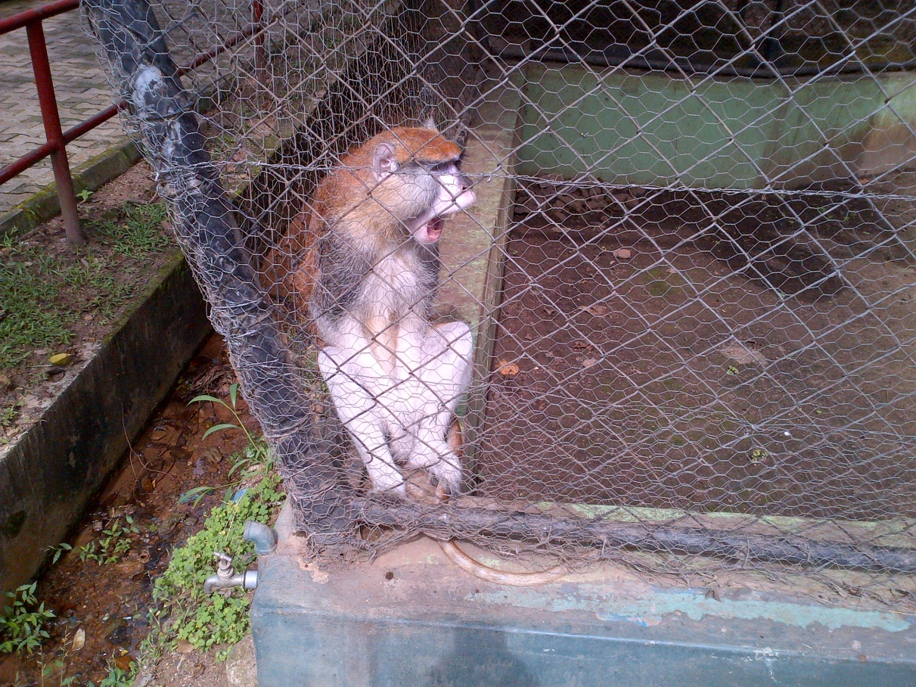
Plate 30: Picture of a Patas monkey at U.I zoo.

Housing structure: At the university of Ibadan zoological garden, the Patas monkeys are housed at different enclosures because of their large number to avoid overcrowding. However their different enclosures are surrounded with thick wire mesh, two of the enclosures has its floor not cemented, while the third one that houses four patas monkey has its floor cemented and the enclosure is very large such that it can house the four patas monkeys. The other two enclosures are not are not very large as it houses only one patas monkey respectively. In each of the enclosures, there is a moat where drinking water is served for them.
Feeding: Just like all other primates at the university of Ibadan zoological garden, the patas monkey is not an exception as it also feeds on the different fruits provided for it. It eats bananas, oranges, pineapples and water melons. During the afternoon period, it feeds on yam mixed with oil and sometimes beans. It is being fed daily.
Behaviour of the Patas monkey in the wild: The patas monkey lives in multi-female groups of up to 60 individuals (although much larger aggregations have been reported). The group contains just one adult male for most of the year. During the breeding season, there are multi-male influxes into the group. Once juvenile males reach sexual maturity (around the age of four years) they leave the group, usually joining all-male groups. The adult females in the group initiate movement of the group with the male following their lead.
4.6.4 General sanitation done in the aviary section
As part of the daily routine in this section, the following was done by me and other industrial training students I was working with during my period in this section and they are:
- The enclosure of all the animals in this are swept daily, although for the chimpanzee its enclosure is being taken care of by one of the zoo keepers in this section.
- The water troughs of these animals are washed regularly.
- Every two weeks for animals whose floors are cemented, their floors and water troughs are always washed with chlorine to remove germs.
- While sweeping their enclosures, their feaces are removed and disposed.
- Removing of cobwebs around their enclosure.
- Sometimes their enclosures are disinfected with disinfectants to avoid predisposing these animals to diseases.
- The grasses growing around their enclosure are always trimmed.

4.6.5 MEDICATIONS FOR THE PRIMATES
Usually at the university of Ibadan zoological garden, the primates are dewormed every three months. The drug used in deworming is pipera vet dewormer. It is injected into the fruits they eat, using a syringe. Also, whenever any animal gets injured and is to be treated, a seductive is usually put into a dart gun and fired at the animal, this causes the animal to be become weak and unconscious and then the treatment is carried out. Usually this is done by the veterinary doctors working with the zoo.
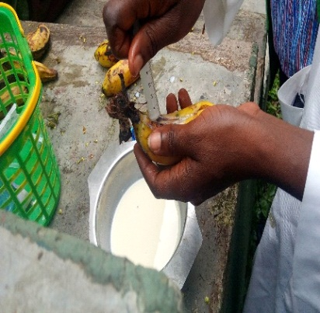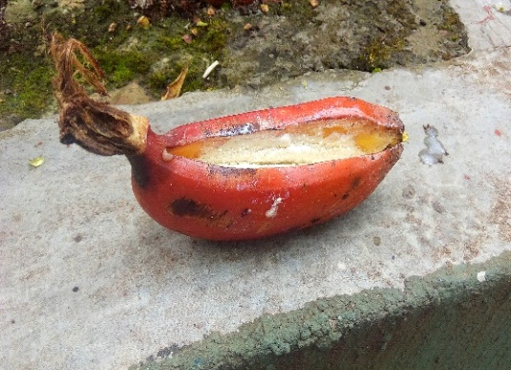
PLATE 31: A PICTURE OF THE VETERINARY DOCTOR PUTTING THE DEWORMING DRUG IN THE FRUITS GIVEN TO THE PRIMATES.

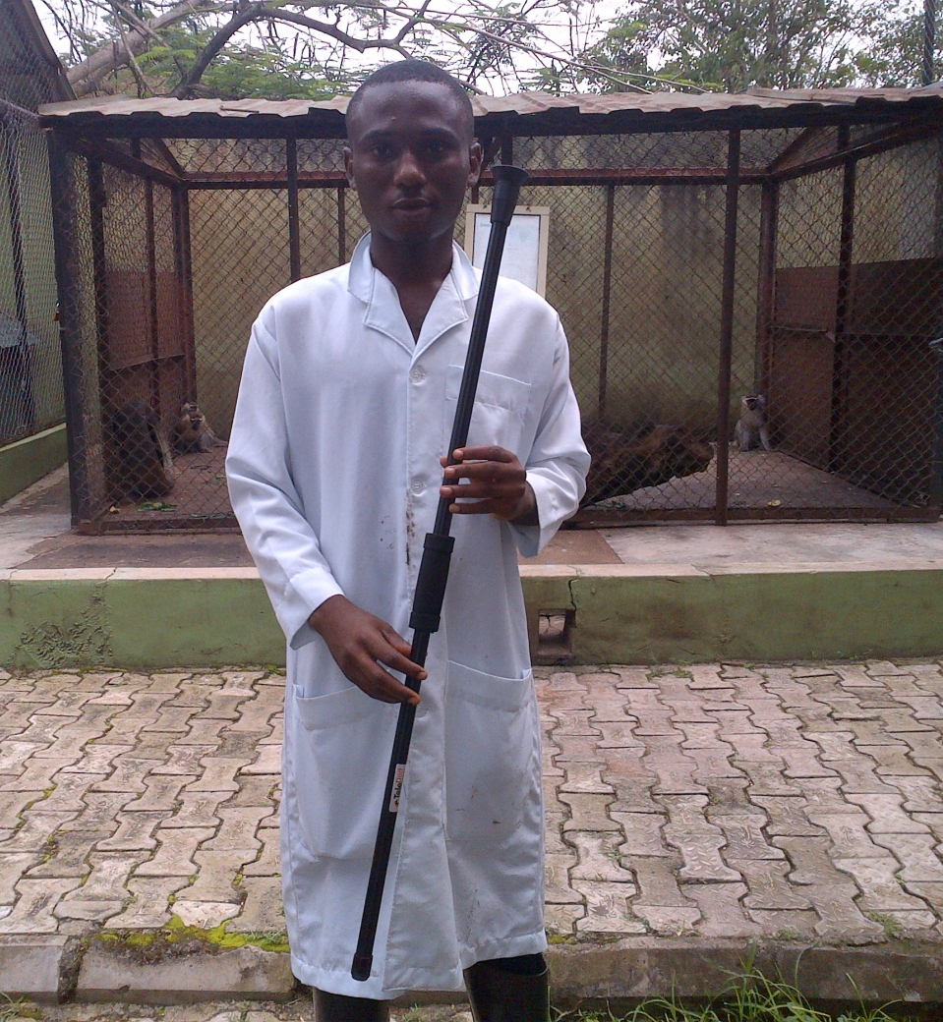
Plate 32: Picture of me holding a dart gun at U.I zoo.

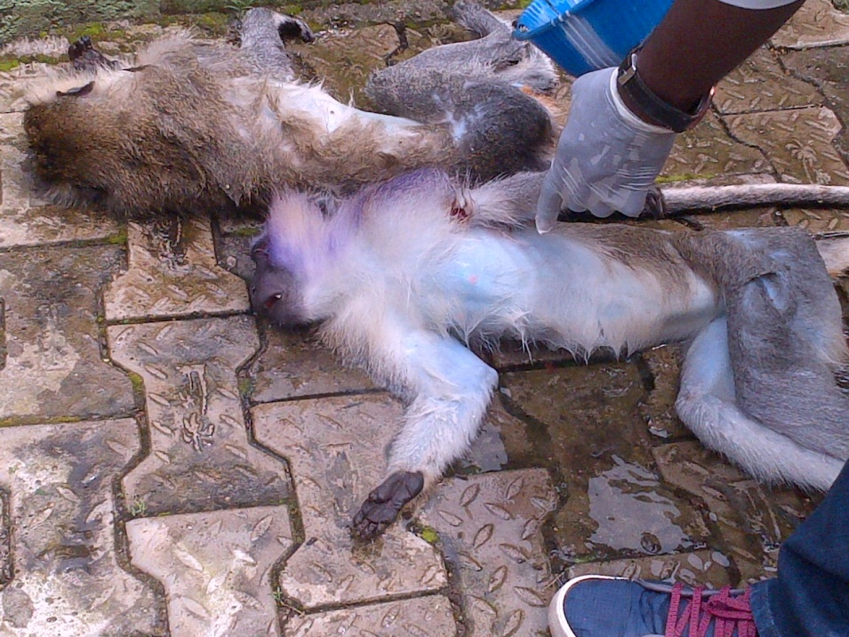
Plate 33: Picture of two green monkeys being treated by the veterinary doctors after they have being darted.

CHAPTER FIVE
5.1 CONCLUSION
The industrial training program set up by the Student Industrial Work Experience Scheme (SIWES) with its aim is to equip students with the practical training of the theoretical work that has been taught in schools, thereby giving students the oppurtunity to be exposed to the usage and operational value of some of the facilities needed in their chosen field later in life.
Therefore, the basic tenets of the SIWES program, some of which has been highlighted in the preceding chapters of this report has been fully reached. Knowledge I learned in the classroom have also been used on the field, and adequate experience has been acquired and if oppurtuned to work in a zoo or any establishment related to such I believe I will deliver adequately.

5.2 RECOMMENDATIONS
- I recommend that in every zoo management adequate facilities for the welfare of the animals, staffs and visitors should be made. Mostly proper feeding, veterinary care and housing enrichment for the animals.
- I also recommend that more staffs should be employed in UI zoo and they should try and acquire rare animal species as well as re-acquisition of dead ones.
- Lastly, it is a known habit of the chimpanzees in the zoo to throw faeces at visitors whenever they are displeased or angry, it will be really good idea for the boundaries between the animal enclosure and visitors to be fully proofed.

