CHAPTER ONE
1.0 INTRODUCTION
1.1 STUDENT INDUSTRIAL WORK EXPERIENCE SCHEME (SIWES)
Student Industrial Work Experience Scheme (SIWES) was established by ITF to solve the problem of lack of adequate practical skills preparatory for employment in industries by Nigerian graduates of tertiary institutions. This program promotes the theoretical education, laboratory and even the workshop practices engaged in by students in tertiary institutions. It is an effort to bridge the gap existing between theory and practice of engineering and technology, science, agriculture, management, and other professional educational programs in the Nigerian tertiary institutions. It is part of government’s plans to improve the skills of students in higher institutions of learning thereby exposing students to machines and equipment, professional work methods and ways of safe guarding the work area and workers in industries and other organizations.
The scheme exposes students to industry based skills necessary for a smooth transition from the classroom to the world of work. It affords students of tertiary institute the opportunity of being familiarized and exposed to the needed experience in handling machinery and equipment which are usually not available in the educational institution.
Participation in SIWES has become a necessary pre-condition for the award of Diploma and Degree certificates in specific disciplines in most institutions of higher learning in the country, in accordance with the education policy of the government.
The program is operated by the Industrial Training Fund (ITF); the coordinating agencies are NUC, NCCE, NBTE, employers of labor, funded by the Federal Government of Nigeria. The beneficiaries are undergraduate students of; Agriculture, Engineering, Technology, Environmental science, Education, pure and applied sciences.

1.2 HISTORY OF SIWES
Student Industrial Work Experience Scheme (SIWES) was established in 1973 to solve the problem of lack of practical skills preparatory for employment in industries. SIWES is a skill development program designed to prepare, expose and enlighten students to the industrial work situation they are likely to meet after graduation. The need for the establishment of the scheme arose when there was a growing concern among industrialists that graduates of institutions of higher learning lacked adequate practical background required for employment in industries. Thus, the employers were of the opinion that the theoretical education in higher institutions was not responsive to the needs of employers of labor. It is funded by the Federal Government of Nigeria and jointly coordinated by the Industrial Training Fund (ITF) and the National Universities Commission (NUC). The scheme also affords students the opportunity of familiarizing and exposing themselves to the needed experience in handling equipment and machinery.
1.3 OBJECTIVES
The industrial training has brought about changes in students, bringing out the potentials of students who diligently partake in the training. Some of the objectives are;
- i. Preparation of students for the work situation they are likely to meet after graduation
ii. To bridge the gap between theory and practical
iii. Provision of an avenue for students in higher institutions to acquire industrial skills and experience during their course of study
iv. Provision of opportunities for students to blend theoretical knowledge acquired in various schools with the practical aspect
v. To produce qualified students with sound practical knowledge coupled with a balanced theoretical knowledge
Vi. To expose students to work methods and techniques in handling equipment and machinery that may not be available in their various schools.

1.4 BRIEF HISTROY OF THE COMPANY
The Federal Institute of Industrial Research Oshodi (FIIRO) is a parastatal under the agency of the Federal Ministry of Science and Technology. FIIRO was the idea of an economic mission sent to Nigeria in 1953 by the World Bank. The mission’s observation was that industrial research activities in Nigeria were diffused and uncoordinated with no definite direction. Consequently, a decision was reached to set the institute in 1956.
1.5 VISION STATEMENT
To be the foremost center for Science and Technology-based research and development for the industrialization and socio-economic advancement of the nation.
1.6 CURRENT AREA OF FOCUS
- Research and Development of Food and Agro-Allied Processing Technologies
- Research and Development into Pulp and Paper Processing
- Research and Development into Packaging and Product Design
- Design and Fabrication of Equipment Prototype

1.7 MANDATE
To assist in accelerating the industrialization of the Nigerian economy through finding utilization for the country’s raw materials and upgrading indigenous production technologies especially to;
- Identifying and characterizing local raw materials for use in industries
- Develop appropriate technologies, upgrading indigenous technologies in the area of food and agro-allied processing and in various non-food use
- Develop pilot scale operations
- Assists in the transfer, adaptation and utilization of these technologies by local enterprises
- Undertake economic evaluation of Projects and consultancy services.

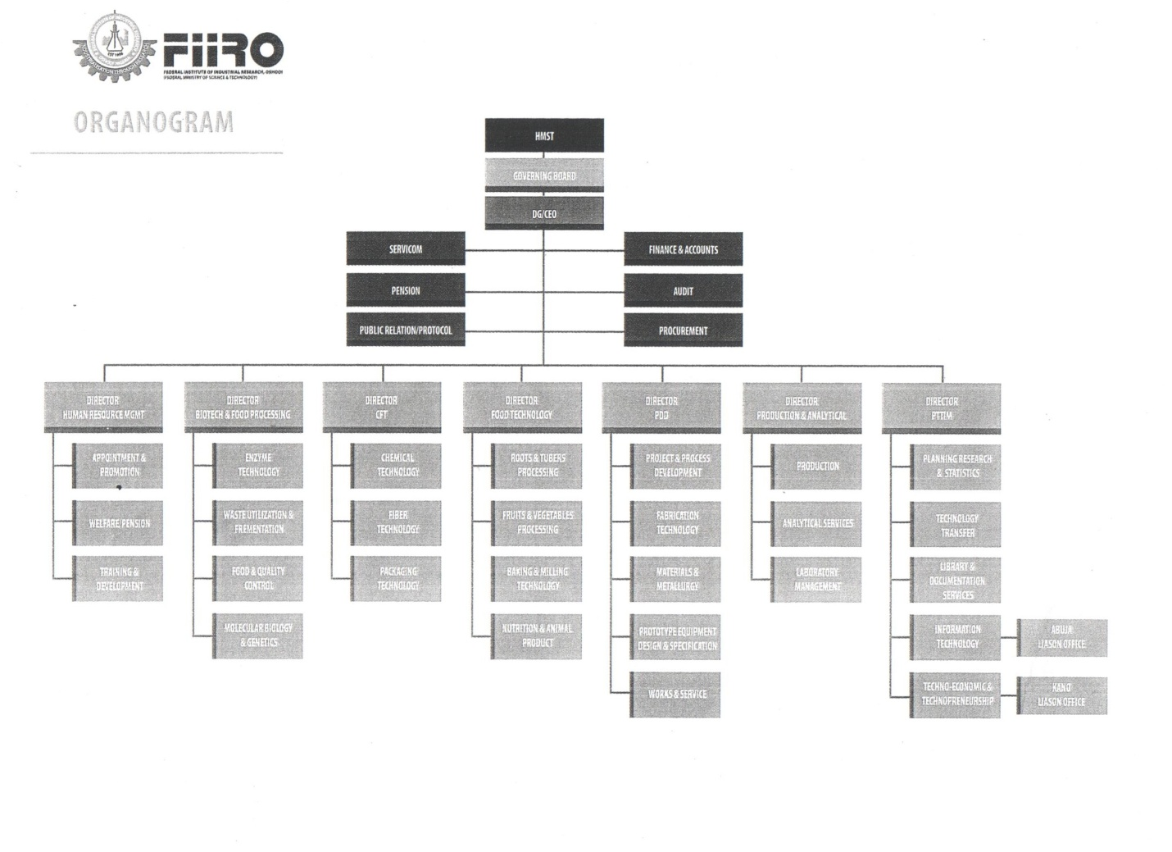FIG 1: ORGANIZATIONAL LAYOUT OF THE FEDERAL INSTITUTE OF INDUSTRIAL RESEARCH OSHODI (FIIRO)

CHAPTER TWO
2.0 DIFFERENT DIVISIONS
2.1 NUTRITION AND TOXICOLOGY LABORATORY
Nutrition and toxicology division is one of the major divisions of the department of food technology with particular mandate on promoting, production and consumption of nutritious and safe processed food for different age groups as well identifying and bridging nutritional gaps for different health related challenges using indigenous carefully selected crops.
The division also conducts nutritional evaluation, sensory evaluation and toxicology studies on established products as critical requirement for food products development prior to consumer acceptability studies. In addition to this, the division carry out research on dietary and management.
- Vision of Division
To be an international center of excellence in Nutrition, Nutraceutical and Functional food technology.
- CURRENT RESEARCH PROJECTS IN THE DIVISION
- Research and development on Nutraceutical and functional food products prevention and management of various diet related and chronic disease condition
- Development and formulations of food for people with special nutritional needs.
- Research into fortification and enrichment.
2.1.1 Production of Rice Milk for Lactose Intolerant Individual
Rice milk is a Lactose free milk (non-diary milk) made from rice. Similar to soy milk and almond milk, rice milk is safe for those who are lactose intolerant. Rice milk is made from boiled rice, it may be sweetened with sugar and some manufacturers use vanilla to make the taste more like cow’s milk. Rice milk contains more carbohydrate than cow’s milk, but it has no cholesterol or lactose, this makes it healthy for the heart. It is fortified with Niacin, vitamin A, Vitamin D, Iron and vitamin B12.
AIM: To produce rice milk from rice grits for lactose intolerant individuals.
RAW MATERIALS: Rice grits, Additives ( vitamin premix, vegetable oil, guar gum, preservatives, emulsifier, salt, sugar), water.
EQUIPMENT: Electric cooker, 250ml barker, Heavy duty blender, pasteurizer.
PROCEDURE: The rice grains were sorted, weighed, and soaked for 1 hour, washed thoroughly and drained. The washed rice was transferred into an electric cooker where it was precooked for 30 minutes, and allowed to cool. Additives were then added, these include: vitamin premix, vegetable oil, guar gum, preservatives, emulsifier, salt, 120g of sugar was weighed into a beaker containing 250ml of water and stirred to obtain a slurry syrup, 50ml of water was added to the vitamin premix and stirred. Wet milling of the rice was done in a warring blender for 2mins and the milk was extracted using a muslin cloth. The additives were added to the milk sequentially and blended for 2mins, pasteurized for 1hr at 80℃ , cooled, bottled and labeled.

RICE GRAINS

Sorting
Weighing
Washing
Soaking (for 3 hours)
Simmering (at 90℃ for 30mins)
Cooling (for 30mins)
Wet milling (at 45 ℃ using medium speed)
Milk extraction (using a muslin cloth)
Addition of additives
Pasteurization (at 80℃ for 30 mins)
Cooling
Bottling
Labeling

RICE MILK
Fig 2: FLOW CHART SHOWING THE PRODUCTION OF RICE MILK

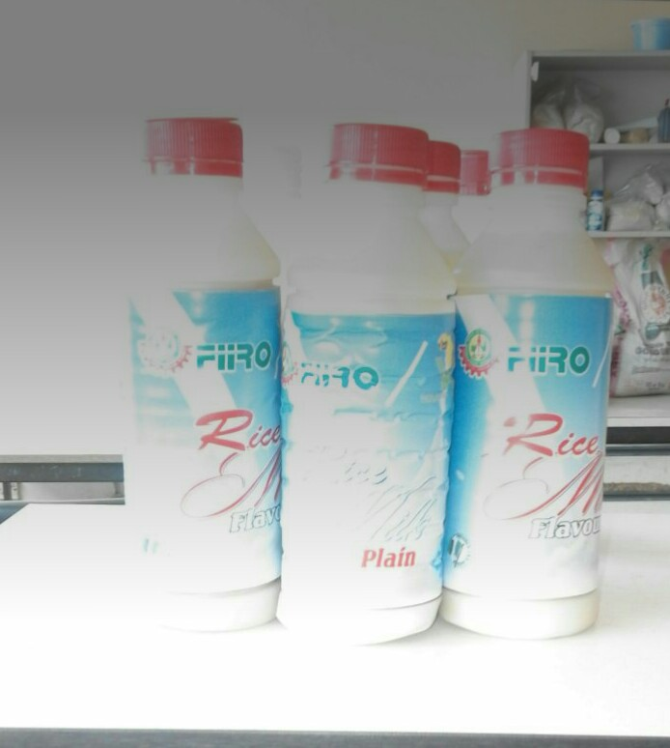
Plate 1. RICE MILK

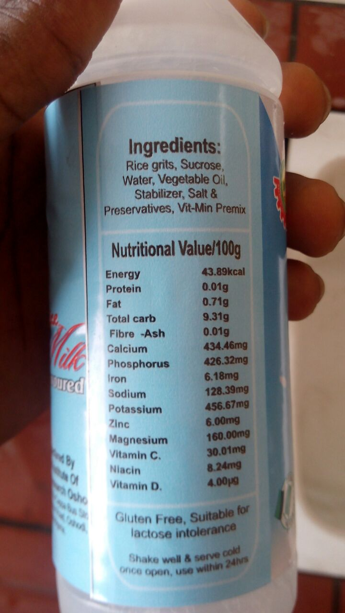
Plate 2. RICE MILK

2.1.2 Production of Vanilla Flavored Soy Milk
Natural Vanilla which is rich in antioxidant contains numerous antioxidants including vanillic acid and vanillin and also lowers cholesterol is used to fortify Soymilk inorder to obtain a high nutritional soymilk drink.
AIM: To produce Soymilk flavoured with vanilla
RAW MATERIAL: Vanilla powder, soybean
EQUIPMENT: Weighing balance, waring blender, pasteurizer.
PROCEDURE:The soybeans was sorted to get rid of the bad ones and foreign materials, weighed, and soaked for 20mins to reduce the toxins and inactivate enzymes. It was drained and cooked for 30mins for easy de-hulling. Wet milling was done in a warring blender and the milk was extracted with a muslin cloth and boiled for 30mins (during which vanilla color powder was added) after which it was sieved again. It was then pasteurized, allowed to cool, and was packaged.

SOYBEANS

Sorting
Weighing
Soaking (for 20mins)
Decanting
Cooking (for 30mins)
De-hulling
Draining
Wet milling
Milk extraction (with muslin cloth)
Boiling (for 30mins with addition of sugar and vanilla color powder)
Sieving
Pasteurization
Cooling
Bottling
SOY MILK

FIG 3: FLOW CHART SHOWING THE PRODUCTION OF VANILLA FLAVORED SOYMILK

2.1.3 Production of Sport Drink using Watermelon
AIM: To produce an incredibly natural and electrolyte filled sport drink in an effort to avoid limit the high amount of sugar and foreign ingredient found in other drinks.
RAW MATERIALS: Watermelon, date Powder, Additives( Nacl, glucose).
EQYIPMENT: Food processor, Gas cooker, pasteurizer.
PROCEDURE: The watermelon was washed, sliced and freed of seeds, the red part was separated from the green part. Size reduction was done part and blended in until a fine paste was got. The paste was left to settle till a clear liquid was got and left to settle for few hours. Afterwards, separation occurred into 2 phases occurred; clear liquid on top and the cloudy material was at the bottom. The clear liquid was decanted into a container and date powder was added. The mixture was left to settle in the refrigerator for 24hrs. Separation into 2 phases also occurred, the clear liquid was also decanted off, 2900ml of water was added and additives (Nacl, glucose) were added and even stirring was done and then heated for a few minutes (pasteurization). It was then allowed to cool and bottled

WATERMELON

Washing
Deseeding
Size reduction
Blending
Settling (for few hours)
Decanting
Settling(for 24 hours)
Decanting
Addition of additives
Pasteurization
Cooling
Bottling
SPORT DRINK
FIG 4: FLOW CHART SHOWING THE PRODUCTION OF SPORT
DRINK USING WATER MELON
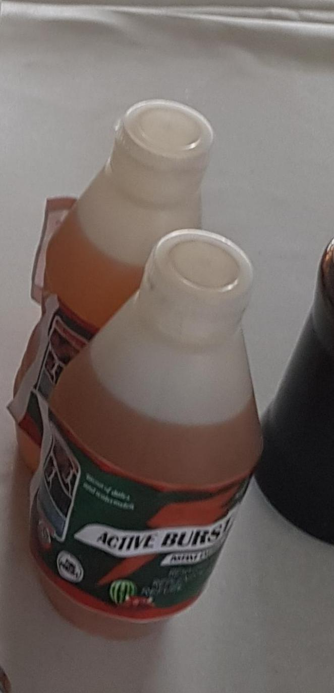
Plate 3: ACTIVE BURST SPORT DRINK

2.1.4 Production of Pineapple Jam
Jam is made by heating juice extracted from fruits with pectin and sugar, heated for a period of time. Fruit preserves are preparations of fruits, vegetables and sugar, often canned or sealed for long-term storage. It is perfect for spreading on toast and can also be used as the foundation for sweet-and-sour sauce or a glaze for roasted meat.
AIM: To produce jam from pineapples
RAW MATERIALS: Wholesome pineapple fruits, water, sugar, lime.
PROCEDURE: The pineapples were weighed on a scale and washed. Peeling was done and it was weighed again. Size reduction was done to aid easy blending of the pineapple and 10% water was added during blending, and it continued till a fine texture was got. The blended materials were then transferred into a pot and allowed to boil to 100℃ and after 20mins, the sugar was added little by little and the brix was checked regularly with a refractometer and stirring was done every 5mins of cooking until 68% brix value was got. The lime water was then added which serves as a PH regulator and a preservative and boiling continued until it set. The jam was then poured in glass jars while still hot and covered.

PINEAPPLES

Washing
Peeling
Size reduction
Blending
Weighing
Boiling (at 100℃)
Addition of sugar and lime
Setting
Hot filling (into jars)
PINEAPPLE JAM

FIG 5: FLOW CHART SHOWNG THE PRODUCTION OF PINEAPPLE JAM

2.2 : PRODUCT DEVELOPMENT DIVISION
The division is dedicated to the processing and utilization of indigenous raw materials such as cereals and legume, fruits and vegetables, meat and fleshy foods, roots and tubers for the development of both intermediate and finished products for the growing population. The division establishes suitable process technologies through research and development (R&D) by upgrading existing traditional technologies for each crop and product of target.
- Vision of division:
To be the core of food-based research and development for sustainability of the economy.
- Mission
To develop value-added products from indigenous raw materials for food security, industrialization and socio-economic development of Nigeria
PRODUCTS FROM THE DIVISION
2.2.1 Production of Orange Jam
AIM: To produce jam from oranges
RAW MATERIALS: Oranges, sugar, lime.
EQUIPMENT: weighing balance, gas cooker, a refractometer, heavy duty blender, jars.
PROCEDURES: The oranges were weighed and washed. After washing, the oranges were peeled and washed again. The juice was extracted from the oranges by squeezing and weighed, the peel was also weighed and the juice and peel were transferred into the warring blender and 10% distilled water was added to the weighed materials and blending was done till a fine texture was got. The blended materials were then poured into a pot and boiled to 100℃ for 20mins. After 20mins, 68% sugar was added little by little and the brix value was taken from time to time with the refractometer until 68% brix value was gotten and then, the lime juice was added which serves as a PH regulator and a preservative and boiling continued. The jam was then allowed to set and poured into jars while still hot and covered.

ORANGES

Washing

Weighing

Peeling

Weighing (peeled oranges)

Juice extraction

Weighing (juice and shaft)

Blending (with 10% water)

Boiling (at 100℃)

Addition of sugar and lime

Setting

Hot filling (into jars)
ORANGE JAM

FIG 6: FLOW CHART SHOWING THE PRODUCTION OF ORANGE JAM

2.2.2 Production of Rice Crisp (Popped)
Rice crisp is another value addition to rice grain. The aim is to produce rice meal from grains which can be consumed as snack and breakfast cereal.
AIM: To produce a value added rice product that can be consumed as snack and ready to eat breakfast cereal.
Equipment: Oven drier, weighing balance, pressure cooker, bowls, thermometer.
Raw materials: Tuwo rice, vitamin premix, malt, vegetable oil, malt, salt, sugar.
PROCDURES: : The rice grains was sorted, weighed, and soaked in water for about 4hrs to aid in easy cooking. The soaked rice was washed and drained. The rice was weighed about 1500g and boiled for 45mins.with the addition of additives such as; malt, vitamin premix, vegetable oil, salt, sugar. After cooking, for 45mins, the rice was transferred into a tray and oven dried for 6hrs and checked at intervals. The dried grains was popped in hot vegetable oil at 180℃ at varying time intervals such as 30sec, 20sec, 15sec, and 10sec to determine the best time for popping, cooled and packaged.

RICE GRAINS
Sorting
Weighing
Soaking for (for 4hrs)
Washing
Draining
Cooking (with additives for 45mins)
Drying (for 6hrs)
Popping (at 180℃ for 30sec)
Cooling
Packaging
RICE CRISP

FIG 7 : FLOW CHART SHOWING THE PRODUCTION OF RICE CRISP (POPPED)
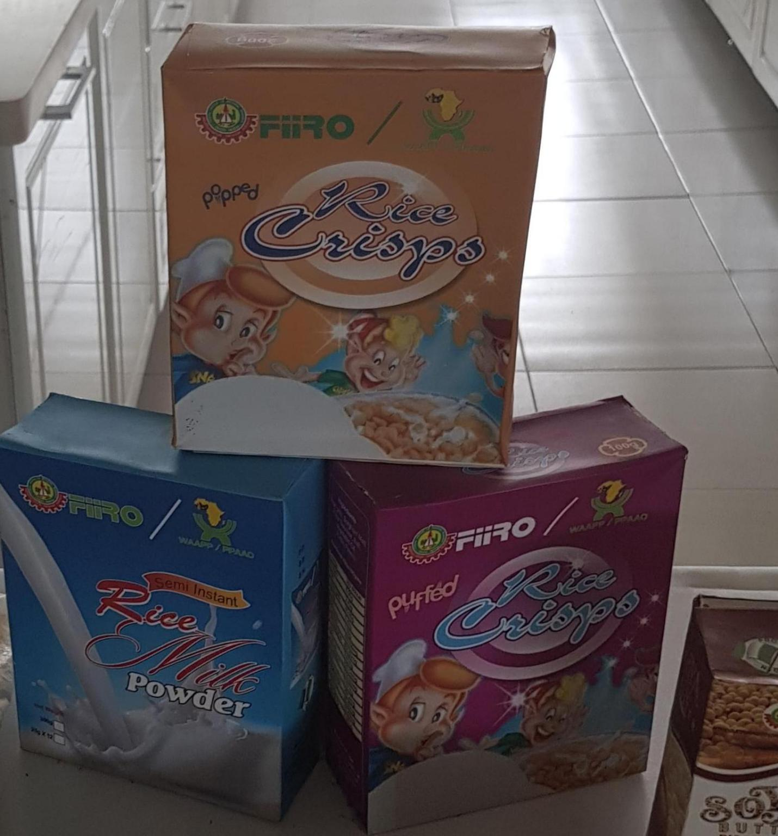
Plate 4: FIIRO RICE CRISP
2.2.3 Production of Malt Drink using Malted Sorghum
Sorghum is a cereal which is used in food industries especially breweries and breakfast cereal meals. In brewing, sorghum can be used as a substitute to barley in malt production.
AIM: To produce malt extract from germinated sorghum rich in vitamins which can be used in brewing and serve as breakfast beverage.
RAW MATERIALS: Sorghum, caramel, hops and sugar.
EQUIPMENT: Oven, dry milling machine, Gas cooker.
PROCEDURE: The sorghum grains obtained from the market was sorted, weighed and steeped for 3days. During the steeping period, the water was changed everyday to reduce fermentation and also to provide oxygen for the hydrolytic enzymes to be active. The grains were spread on a germination tray for germination to occur for 4days. The germinated grains was dried in the oven for 3hrs at a temperature of 60℃ after which it was kilned at higher temperature to obtain a dark brown color. The malted grains was then crushed using a mortar and pestle in order to expose the starch endosperm for easy extraction.
The crushed grains called GRIT was mashed to break down the starch, protein and other components such as the β and α amylase after which water was heated up to 75℃ which is the gelatinization temperature for sorghum grains and the mash was incorporated into it for a few minutes and sieved to produce the WORT. The wort was boiled for 30mins with the addition of caramel and hops and sugar and further boiling was done. It was then cooled and bottled.

RAW SORGHUM GRAINS
Sorting
Weighing
Steeping (3days)
Draining
Germination (3days)
Drying (@60℃)
Kilning
Winnowing
Crushing
Mashing
Sieving
WORT
Wort boiling
Addition of caramel and hops
Addition of sugar
Further wort boiling
Cooling
Bottling
MALT DRINK

FIG 8: FLOW CHART SHOWING THE PRODUCTION OF MALT DRINK.
2.2.4 Production of soy Cheese
The soybean seeds were sorted, weighed and 1.6kg of the soybean was soaked for 20mins to reduce the toxins and inactivate the enzymes present. It was drained and pre-cooked for 30mins for easy dehulling and wet milling was done in the warring blender using 3.450ml of water and this made up the composition of 1: 2 of the soybean and water used. This ratio will give a thick extract and not watery. After the soybean was completely milled, the milk was extracted with a muslin cloth and 2000ml of the soybean milk was put in a clean pot and boiled for a few mins and then the coagulant used which is Bombom leaf extract ( Calotropis procera) also known as sodom Apple was added about 350ml. This was allowed to boil for about 45mins until the separation/ coagulation/ curdling was completed. After that the curd was carefully separated from the whey by carefully scooping the curd into a clean muslin cloth. Using a screw press, the rest of the whey was removed and the cheese was then placed on foiled drier trays and taken to the oven drier for drying. It was dried at the temperature of 60°c . It actually took about 3 days for it to get completely dried and very crunchy at this temperature. It was then milled and packaged in a well sealed material for further use in Biotechnology analysis and production.

SOYBEANS

Sorting
weighing
Soaking
Draining
Boiling (for 30mins)
De-hulling( done manually)
Wet milling
Sieving
SOYMILK
Heating
Addition of coagulant
Heating continued
Phase separation (whey on top, cheese at the bottom)
Draining (with muslin cloth)
Screw pressing ( to remove remaining whey)
Drying( at 60°c)
Packaging
SOY CHEESE

FIG 9 : FLOW CHART SHOWING THE PRODUCTION OF SOY CHEESE

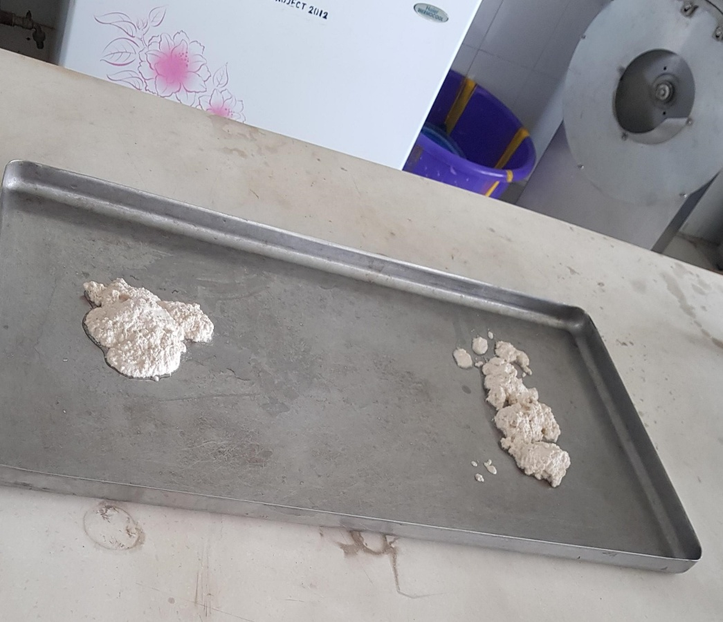

Plate 5: CURD FORMED FROM SOY MILK BEFROE DRYING
2.2.5 Production of Coconut oil
Coconut oil is an edible oil extracted from the kernel or meat of mature coconuts harvested from the coconut palm. It has various applications: for cooking, especially for frying, baking, livestock feed, hair treatment among other uses. There are 2 methods of oil extraction; hot process and the cold process
AIM: TO PRODUCE COCONUT OIL USING HOT PROCESS
RAW MATERIAL: Coconut fruits
EQUIPMENT: Weighing balance, heavy duty waring blender.
PROCEDURE: The coconuts obtained from the market were broken, de-husked, weighed and washed very well. Size reduction was done with knives and milling was done using a warring blender. 8litres of water was added to the milled materials and mixed very well. The milk was extracted with a muslin cloth and left overnight to ferment. The curd produced was scooped off and heated using medium heat. The oil produced was scooped off and left to decant overnight. Pure coconut oil was produced following the decanting process and bottled.

COCONUTS
De-husking
Weighing
Washing
Size reduction
Milling
Addition of water (8litres)
Milk extraction (with muslin cloth)
Settling (for 1 day)
Curd
Heating (with medium heat)
Decanting (for 1 day)
Bottling

COCONUT OIL

FIG 10: FLOW CHART SHOWING THE PRODUCTION OF COCONUT OIL

Plate 6 : Virgin coconut oil
Plate 6 : Virgin Coconut oil

Plate 6 : Virgin Coconut oil
VIRGIN COC

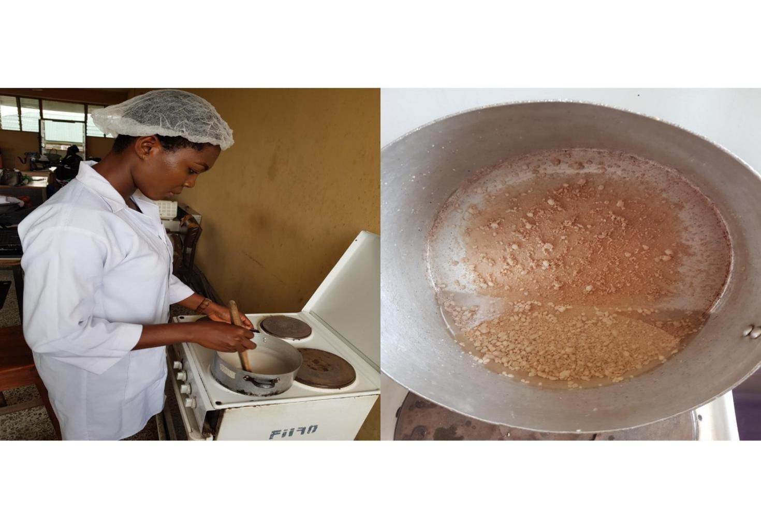
2.2.6 Production of Peanut Butter
Peanut butter is a food paste made primarily from ground dry roasted peanuts. In a 100gram amount, peanut butter contains 588cal and composed of 50% fat, 25% protein,20% carbohydrate, 6% dietary fibre and 2% water.
AIM: To produce peanut butter used as a complimentary food.
RAW MATERIALS: Peanut, salt, corn starch.
EQUIPMENT: Food blender, sterile jars.
PROCEDURE:The groundnuts were sorted to separate the good ones from the bad ones. The good nuts were weighed and roasted in the halogen oven @ 160 ℃ for 90mins till a dark brown color was got. The roasted nuts were then allowed to cool and de-hulled. The de-hulled nuts were then milled in a blender. Halfway through milling, a measured quantity of salt was added and stirred. Towards the end of milling, corn starch was also stirred into the blend and milling continued till a fine, smooth paste was got. It was then packed into sterile jars and labeled.

GROUNDUTS

Sorting
Weighing
Roasting (@ 160℃ for 90mins)
Cooling
Milling (addition of salt and corn starch)
Cooling
Packaging
PEANUT BUTTER

FIG 11: FLOW CHART SHOWING THE PRODUCTION OF PEANUT BUTTER
2.3 BAKING AND MILLING DIVISION
The division was established to conduct research and development into food and agro-allies.
Processing technologies;
- Milling specification of locally available grain (corn, sorghum, millet, etc),tuber (yam, sweet and Irish potato) and other agricultural produce such as plantain and banana.
- Utilization of locally obtained flours from indigenous food crops for product development to promote value chain addition.
- Technology transfer through training programs and workshops for investors and small and medium scale entrepreneurs.

PRODUCTS OF THE DIVISION
2.3.1 Production of soy Flour
Soy bean (Glycine max) is a species of legume normally eaten for its proteinous content. Mature soybean contains about 38% protein, 30% carbohydrate, 18% oil, and 14% moisture, ash and hull. This soy flour substituted as a composite flour in baking, it is used in food fortification like in production of FIIRO soy ogi.
AIM: To produce a high nutritional flour from soybean used in many food production processes
RAW MATERIAL: Soybean seed.
EQUIOMENT: Hammer mill, de-hulling machine.
PROCEDURE:The soybeans were sorted, weighed and soaked in water for 20mins to reduce toxic substances and inactivate enzymes, the water was then drained off. The beans were boiled on a steam cooker for 30-50mins, to soften the beans for easy de-hulling. The water was drained off and de-hulled beans was oven dried at 65℃ for 8hrs. The dried beans was milled into fine particles and packaged.

SOYBEANS

Sorting
Weighing
Soaking (for 20mins)
Decanting
Boiling (for 30-50mins)
De-hulling
Draining
Drying (at 65℃)
Packaging
SOY FLOUR

FIG 12: FLOW CHART SHOWING THE PRODUCTION OF SOY FLOUR

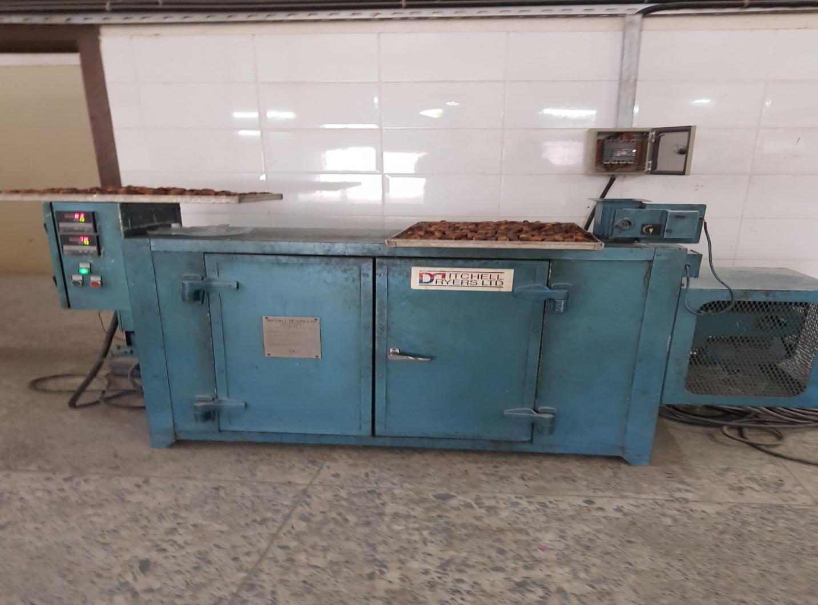
Plate 7: Cabinet drier used in drying Soy Bean

2.3.2 Production of Rice Flour
Rice flour is one of the varieties of products obtained from rice grains. The aim of rice flour production is to derive different forms in which rice can be processed into, with the sole aim of increasing it palatability. (Value addition).
AIM: To produce high quality rice flour for use in different food research and food production processes.
RAW MATERIAL: Rice.
EQUIPMENT: Hammer mill.
PROCEDURE: The rice grains were sorted to get rid of foreign materials, weighed and soaked for 2hrs, then drained It was then oven-dried with mild heat and routinely checked until fully dried. The fully dried rice grains was then milled with hammer mill and sieved to obtain fine particles, and packaged.

RICE GRAINS
Sorting
Weighing
Soaking (for 2hrs)
Draining
Drying (oven)
Milling (Hammer mill)
Cooling
Packaging
RICE FLOUR
FIG 13: FLOW CHART SHOWING THE PRODUCTION OF RICE FLOUR

2.3.3 Production of Plantain Flour
Plantains are a solid source of carbohydrates with a low fat content, but they also provide a number of other health benefits as well. Plus, they don’t contain any significant level of toxins. Plantain flour can be used in baking, prepared as a meal to be taken with stew.
AIM:To produce nutritious flour from unripe plantains.
RAW MATERIAL: Unripe plantain.
EQUIPMENT: Cabinet dryer, hammer mill.
PROCEURE:The unripe plantains obtained from the market was weighed and blanched in a water bath of about 70-75℃ and was peeled using a knife and then size reduction was done with a slicer in order to maintain uniformity. Then drying was done using a cabinet dryer at 65-70℃ and checked at intervals to avoid the materials getting burnt. Milling was then done in the hammer mill and was cooled, then packaged.
REASONS FOR BLANCHING
- To soften the tissues
- To inactivate the enzymes, thereby preventing browning action from taking place
- For easy removal of the peel
REASONS FOR SIZE REDUCTION
- To increase the surface area
- To reduce drying time
- To conserve energy

UNRIPE PLANTAINS
Sorting
Weighing
Blanching
Peeling
Size reduction
Drying
Milling
Cooling
Packaging
PLANTAIN FLOUR
FIG 14: FLOW CHART SHOWING THE PRODUCTION OF PLANTAIN
FLOUR
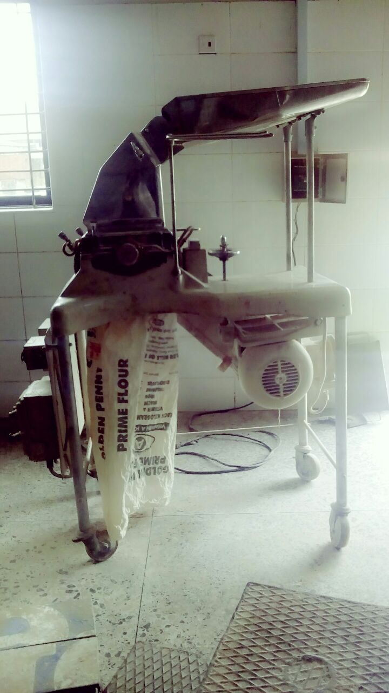
Plate 8: A hammer mill used in milling the unripe plantain.
2.3.4: PRODUCTION OF BEAN FLOUR
Bean (cowpea) is an important source of carbohydrate and protein locally sorted in all region of Nigeria. The cowpea grain contains about 25% protein, 64% carbohydrate and it’s potential in alleviation of malnutrition is inestimable. Bean flour is used in the preparation of moi-moi (steamed cowpea paste), akara (fried cowpea paste) among other products.
AIM: To produce high quality bean flour from beans.
RAW MATERIAL: Brown Bean seeds
PROCEDURE :The bean seeds were sorted, and the stones and dirts were removed. The clean seeds were weighed and soaked in water for some minutes after which it was de-hulled.
The de-hulled beans was then washed thoroughly and dried in the cabinet dryer at 65℃ for 6hrs. After drying, milling was done using the hammer mill, cooled and packaged.

BEAN SEEDS
Sorting
Weighing
Soaking
De-hulling
Draining
Drying
Milling
Cooling
Packaging
BEAN FLOUR
FIG 15: FLOW CHART SHOWING THE PRODUCTION OF BEAN
FLOUR
2.3.5: PROCESSING OF COCONUT VALUE ADDED PRODUCTS
Coconut(cocos nucifera) is one of the most important crops in tropical areas. The coconut provides a wholesome and nutritious source of meat, milk, water and oil. This serves as a good beverage for sport drink because it contains large amount of minerals such as sodium, potassium, chloride, phosphorous, magnesium, ascorbic acids, Vitamin B and sugars. It is also rich in amino acids like arginine, alone and cystine. Amongst the products produces where;
- Coconut syrup
- Dessicated coconut
- Coconut milk
- Coconut fibre
- Coconut oil
2.3.5.1 : PRODUCTION OF COCNUT SYRUP
Coconut syrup is a translucent nutty flavoured free flowing liquid produced from coconut milk. It is used as topping for bakery product or as a mixer in alcoholic drinks, or maybe diluted with water and used in preparation of cakes and other delicacies. Coconut is also considered as a functional food.
AIM: To produce coconut syrup used in food and beverage.
RAW MATERIALS: Coconut, sugar, salt, water, corn starch.
EQUIPMENT: Heavy duty blender, thermometer, Gas cooker.
PROCEDURE: The coconut was deshelled/ dehusked, It was then sorted for good and wholesome ones. 400g was then weighed and the size was reduced using knives. It was then put into a heavy duty blender for milling and 800ml of water was added. After thorough milling, it was sieved and the coconut milk was gotten. 1000ml of coconut milk was measured using a measuring cylinder and 200g of corn starch was added and mixed thoroughly and the mixture was poured into a clean pot. The coconut milk was then heated to 60°c ( it was checked at intervals using a thermometer). At this temperature, 100g of sugar was added and heating continues, and at 80°c, ½ teaspoon of salt was added and heating continues until bubbles starts coming at a temperature of about 95°c. At this temperature the heat was turned off and the syrup was allowed to cool. It was then filled into clean and already sterilized air tight jars and closed very well.

COCONUT
De-husking
Sorting
Weighing(400g)
Washing
Size reduction
Addition of water(800ml)
Milling
Milk extraction (with muslin cloth)
Weighing(1000ml)
Addition of corn starch(200g)
Heating (to 60°c)
Addition of sugar(100g)
Heating( to 80°c)
Addition of salt( ½ teaspoon)
Heating continues until bubbles starts coming out(at 95°c)
Cooling
Bottling
COCONUT SYRUP

FIG 16: Flow chart for the production of coconut syrup.

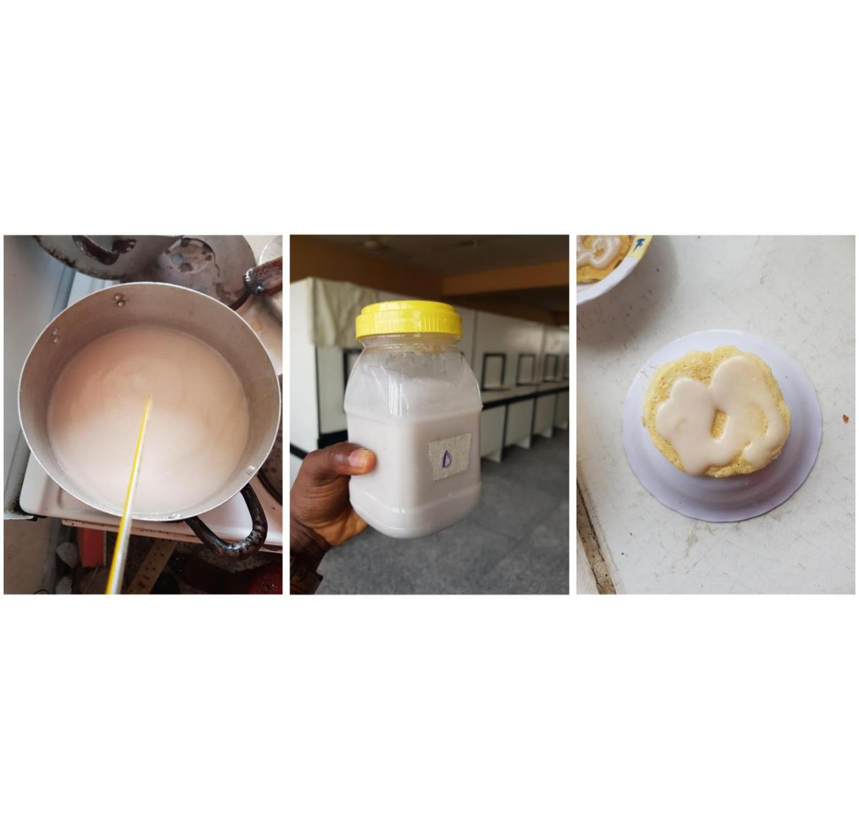
Plate 9 : Coconut Syrup

2.3.5.2: PRODUCTION OF DESSICATED COCONUT
Dessicated coconut is produced by drying shredded ground coconut after separation from the brown testa. It is widely used in confectioneries,baking, pudding and ice creams. Dessicated coconut can be added to food for it’s texture, added coconut flavour, garnish for savory foods, as a dusting for the outer layer and as a substitute to raw grated coconut.
AIM: To produce dessicated coconut with prolonged shelf life used in baking and confectioneries.
RAW MATERIAL: Coconut separated from the testa.
EQUIPMENT: Oven drier.
PROCEDURE: The already dehusked/ deshelled coconut from the coconut syrup produced was scraped to remove the testa and retain just the white part. The cocnut was steam blanched for 30mins. It was then washed thoroughly and Grater was then used to create the coconut into slimmer and longer shapes. It was washed thoroughly again and then spread out on foiled drier trays for drying. It was dried in hot air oven drier at a temperature of 90°c until the mixture content was about 3%. This was confirmed using a moisture analyser.

COCONUT
Dehusking/ de-hulling
Sorting
weighing
Washing
Removal of the testa
Steam blanching
Drying(90°c)
Packaging
DESSICATED COCONUT
FIG 17: Flow chart for the production of dessicated coconut.

2.3.5.3: PRODUCTION OF COCONUT FIBRE
Coconut fibre this is gotten from the coconut shaft after the milk is removed the milled coconut. This can be used in baking for production of high fibre products for the management of obesity.
AIM: To produce coconut fibre which is incorporated in foods for management of obesity.
RAW MATERIAL: Coconut
EQUIPMENT: Waring blender and Hot air oven.
PROCEDURE: The coconut is deshelled/ dehusked. It is then weighed to get the desired amount of yield. It was then washed thoroughly with clean water and a measure amount of water was added to it and then milled using a Waring blender. The milk was extracted using a muslin cloth. To the residue, hot water was added to it and allowed to stand for about 30mins to reduce the microbial count and for a prolonged shelf life. It was then dried in a hot air oven at the temperature of 80°c.

COCONUT
Dehusking/ de-hulling
Sorting
weighing
Washing
Milling
Extraction of milk
Steam blanching of the residue
Drying(80°c)
Packaging
COCONUT FIBRE
FIG 18: Flow chart for the production of coconut fibre
2.3.5.4: PRODUCTION OF COCONUT MILK
Coconut milk is a dairy-free milk, rich in fat and also cholesterol-free. It is a perfect alternative for people pursuing lactose-intolerant food. Coconut milk is rich in many nutrients.
AIM: To produce milk from coconut which is rich in potassium, iron, sodium, vitamins, carbohydrate and protein.
RAW MATERIAL: Coconut
EQUIPMENT: Waring blender.
PROCEDURE: The coconut was deshelled/ dehusked. It was sorted and washed thoroughly. Afterwards weighed and blended using a small amount of water. The slurry was then sieved using a muslin cloth and then the residue was squeezed thoroughly till all the milk was extracted from it. The milk was then pasteurized, cooled and packaged.

COCONUT
Dehusking/ de-hulling
Sorting
weighing
Washing
Milling
Extraction of milk
Thorough squeezing
Pasteurizing
Packaging
COCONUT MILK
FIG 19: Flow chart for the production of coconut milk.

2.3.6: QUALITY CONTROL

Quality control is the set of measures and procedure to follow in order to ensure that the quality of a product is maintained and improved against a set of benchmark and that any errors encountered are either eliminated or reduced. The analytical laboratory of the Federal institute of industrial Research, Oshodi (FIIRO-ANALAB), is a well-equipment professionally and skillfully manned by trained experts/analysts. FIIRO’s analytical laboratory undertakes routine quality control and safety evaluation checks on foods and food products for the purposes registration of the products with National Agency for Food Drug Administration and control (NAFDAC) and for ascertaining standards specifications as set down by standard Organization of Nigeria (SON).
These include:
Protein, total sugar, starch, Ether extract, crude fiber, ash, carbohydrate, trace elements, vitamins and cholesterol.

2.3.6.1: Determination of the Swelling Index of Flour
Samples
- Weigh 10g of the flour sample
- Measure about 60ml of water in 100ml measuring cylinder
- Introduce the 10g sample carefully into the measuring cylinder and mix very well
- After thorough mixing, make up the water to 100ml
- Take the reading immediately i.e. the level of the sample in the water, from the zero reading
- Monitor the change in sample level at every 5mins for a period of 1hr
- Then plot a graph of level of sample against minutes starting from 0min
N.B: This is one of the functional properties of flour sample.
2.3.6.2 Determination of the Bulk Density of Flour Samples
Bulk density can be simply defined as the measure of packaging. There are 2 ways to calculate bulk density,
- Loose Bulk Density
- Tapped or Packed Bulk Density

LOOSE BULK DENSITY
- A dish with a regular shape and size was placed on the digital weighing scale and the reading was recorded three times
- The dish was filled with the flour sample and weighed with a digital weighing scale
- The reading was taken and the process was repeated three times to get the average weight of the flour
Density = mass
Volume
Weight of dish = Wt₁+Wt₂+Wt₃
3
TAPPED OR PACKED BULK DENSITY
- A dish with a regular shape and size was filled with the flour sample
- Tapping was done three times and filled with more flour and tapped again
- It was placed on the weighing scale and the reading was taken. The process was repeated three times to get the average weight of the flour.
Weight of the dish + sample= W₁+W₂+W₃
3
Average weight of the sample= Average weight of dish+ sample- average weight of dish

VOLUME OF THE DISH
- To get the volume of the dish, the dish was filled with water and the water was transferred into a measuring cylinder and the reading was taken.
- This was done three times to determine the average volume of the dish
BULK DENSITY= Weight of the sample
Volume of the dish

CHAPTER THREE
3.1 EQUIPMENT AND EQUIPMENT MAINTENANCE
General there are different types of instruments/equipment used in different laboratories with each unique for the specific function it performs, for example the HPLC machine (High Performance Liquid Chromatography) for detection of vitamins present in food, this is used in the HPLC/world bank laboratory. There are some machines, apparatus and glassware commonly found in all labs and processing pavilion, like the, hammer mill, colloidal mill, weighing balance, beakers, retorts stand used to carry out analysis, machines in good operating conditions are a necessity in any production line. This level of integrity can be achieved by a regular maintenance schedule with minimal work. Maintenance is beneficial as it; increases instrument lifetime, reduces downtime, overall improvement in instrument performance; giving the operator greater confidence in the validity of his/ her analytical result and desired result during processing.
3.1.1 Equipment’s /Machines used in Laboratories and Production Section
their Functions and Maintenance
All glassware used in the laboratory are used to carry out analysis, like the burette and conical flask used for collecting sample of food, measuring cylinder used to measure water and food samples, then all machines in the pavilion like cabinet drier, hammer mill, colloidal mill, okro slicer . In maintaining them; they must be properly washed using appropriate detergent, rinsed and disinfected properly and then stored in already marked out cabinet for safe keeping, machines in pavilion are steadily sanitized. Each apparatus has its own cabinet for quick and easy accessibility when an analysis is about to be carried out in the laboratory.
- Hot Air Oven: it is an electrical device which uses dry air to sterilize and dry food sample, they operate at 50º to 300º using a thermostat to control the temperature. Their double walled Insulation keeps the heat in and conserves energy, the inner layer been a poor conductor and the outer layer being metallic. It is used for drying glassware or drying sample which contain water or other solvent for further analysis or testing procedures.
In maintaining the hot air oven it must be ensured that the power source is turned off to prevent the hazard of electrocution; take out the trays from the oven and place in a safe place, use a lint free clothed dipped in disinfectant and clean the internal surface of the equipment, the trays are cleaned using disinfectant and placed back in the oven. Use a clean dry lint free cloth to clean the external surface of the oven. This is done once a week except when there is spillage of fumes or food sample that can cause corrosion to the stainless steel chamber then cleaning is required. Calibration of the temperature controller and sensor is done once in 6 months.
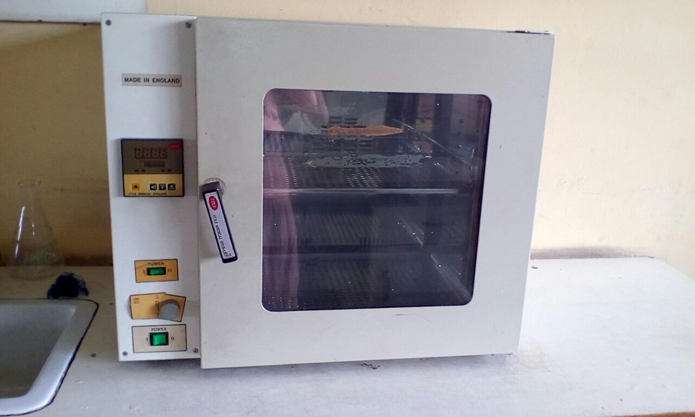
Plate 10: HOT AIR OVEN

2 .Weighing balance: It is an instrument used for weighing food samples. It gives an accurate representation of the weight of a sample if properly calibrated. In maintaining the weighing balance we carry out daily and bi-annual cleaning.

Safety Checks - Daily:
- Check that electrical connections are fully coupled, that cords are not frayed and that there is no liquid on or about the balance
- Unidentified spilt chemicals should be removed with extreme caution whilst wearing standard SimuLab PPE (for details of cleaning, see the cleaning section below).
Set-up and Pre-use Checks - Daily:
- Ensure that the Instrument Room and the balance doors are closed to minimise draughts.
- Check the level, and if necessary, level the balance using the leg ferrule adjusters and the in-built spirit level.
Turn the balance on at the wall and press the Start button.
- Allow five minutes for the electronics to warm up.
- Press the Zero button and ensure that the balance reads 0.0000 +/- 0.0003 g. Press the Zero button once more to place the balance into Standby mode. An orange Standby light will now glow
Calibration Checks - Bi-annually:
- Press zero button and check that digital readout reads 0.0000 +/- 0.0003 g within 4 seconds. Repeat once if digital readout fails to display 0.0000 g within 4 seconds.
- Press the calibration button. The balance will run through a calibration and zeroing check procedure and signal 'Cal OK' in the digital readout. If Cal OK does not appear within one minute, repeat the procedure once.
- Check the Accuracy of the balance by carefully weighing check weights, which are located in the marked box in the drawer adjacent to the analytical balance. Always use the forceps provided to handle the calibration weights. Do NOT handle weights with fingers.Use weights 1.0 g and 0.01 g. Acceptable ranges for each of the weights are:
1.0 g: 0.9980 - 1.0020 g
0.01 g: 0.0090 - 0.0110 g
Always weigh the 1.0 g weight FIRST.
- Check the Precision of the balance by weighing the 1.0 g weight consecutively ten times. Calculate the standard deviation (SD). Acceptable SD is up to 0.02.
- If the balance fails any of the four checks above, contact the Metcalfe Servicing Division.
- Return the balance to Standby mode.
Cleaning - Daily or as Required:
- Carefully remove the balance pan, clean and replace it.
- Mop up any spilt liquids and brush any spilt chemicals from the weighing chamber. Clean the glass doors (inside and out), using a soft cloth and 80% v/v ethanol.
- Remove dust from the exterior of the cabinet and clean up any spilt chemicals from the balance bench area.
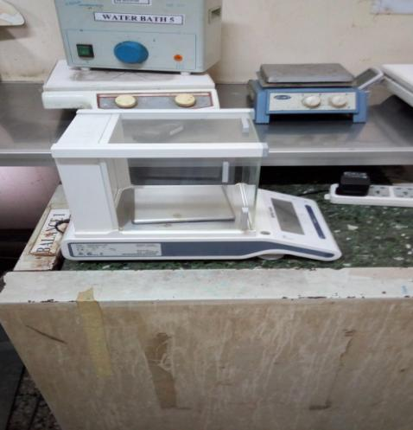
Plate 11: WEIGHING BALANCE
- Moisture Analyzer: It is an instrument used for the determination of the moisture content of a sample with the loss on drying method and consists of a weighing and heating unit (infrared). It is often also called moisture balance or moisture meter.
To maintain productivity, your equipment must perform reliably for each measurement. The accuracy of a moisture analyzer depends on many factors.
Ideally the moisture analyzer will be permanently positioned in a protected area away from drift, dust and temperature extremes that can affect accuracy and repeatability.

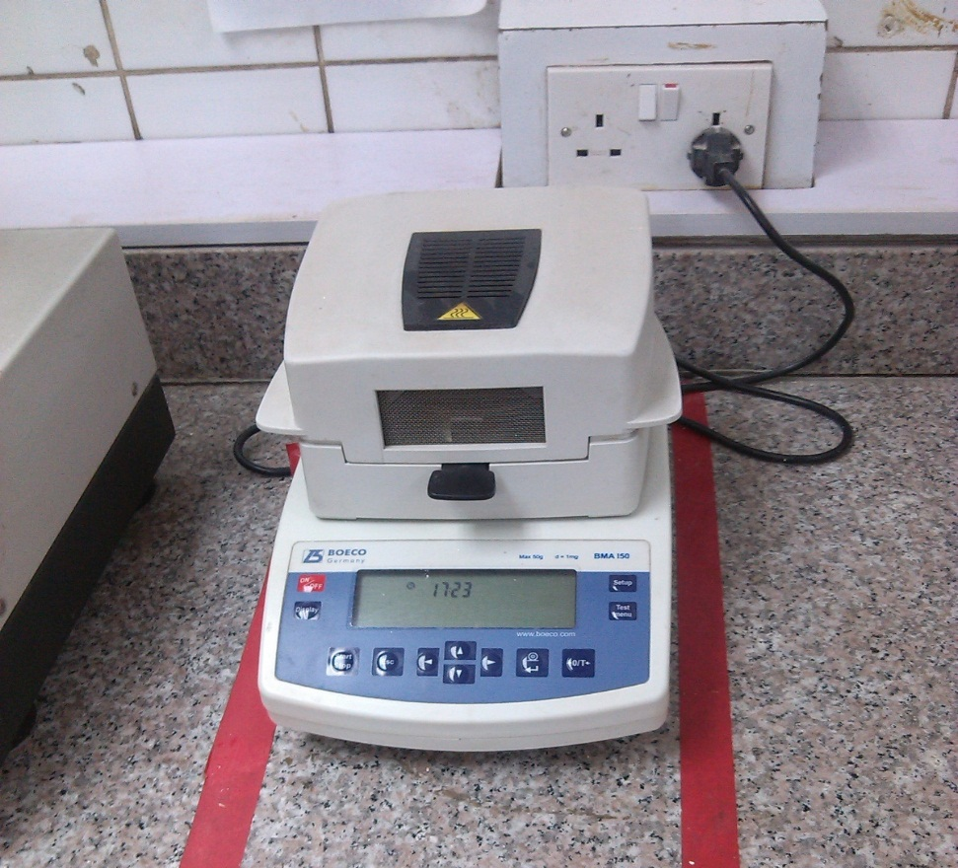
Plate 12: MOISTURE ANALYZER
4.. PASTEURIZER: Equipment used to pasteurize food liquid such as milk, fruit juice. The material is passed continuously over heated plates or through pipes, where it is heated to the required temperature, maintained for the required time, the immediately cooled.
The pasteurizer been equipment used for sensitive food material, is sterilized after each process of pasteurization with ethanol. The metal part is routinely checked for spillage from the joints. The power source is also checked to avoid bridge in connection.
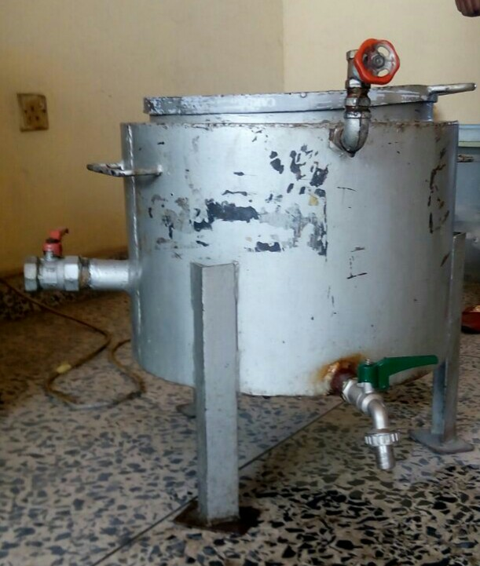
Plate 13: PASTEURIZER

5. Heavy Duty Blender: It is a machine with one horse power motors and beyond. It has the ability to crush ice and heavy duty food raw materials.
The cup which houses the blade is always wash after usage to avoid spoilage or contamination of other food materials.
Avoid using the blender when the power adapter is not in place. The cleaning of the steel part of the machine is weekly done by the students attached to the laboratory.
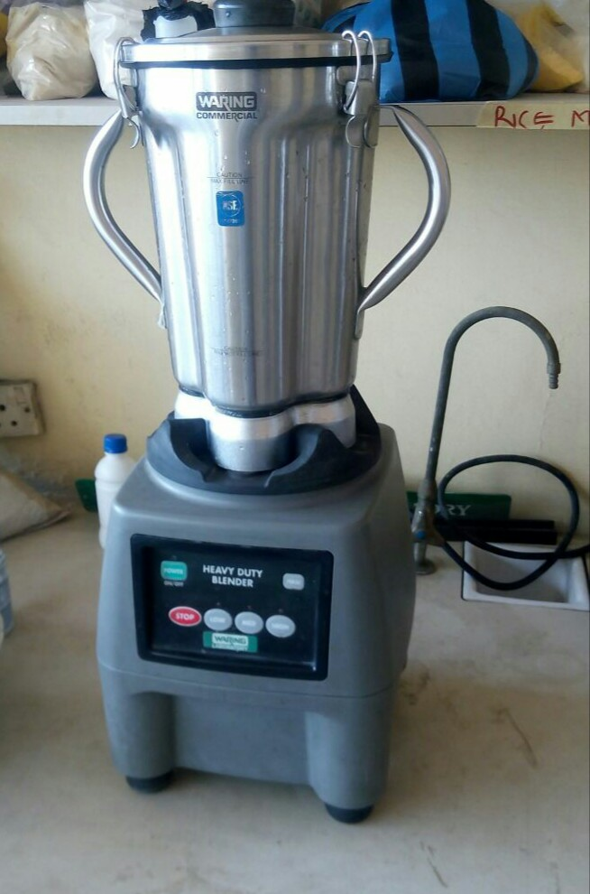
Plate 14: WARING BLENDER

7. Hammer mill: Hammer mill is a mill used for the purpose of shredding or crushing aggregate material into smaller pieces by the repeated blows of little hammers.
The hammer mill is usually blown after each milling operation.
Plate 15: HAMMER MILL

CHAPTER FOUR
4:1: PROBLEMS ENCOUNTERED DURING THE PROGRAMME
Apart from the benefits and experience gained during the industrial training program, the problem encounter during this training can deviate must students from their obligations if most of these serious problems are not properly addressed;
- FIIRO does not allow I.T students to use some of their equipment and machines as such reduces the chances of the students to practice the analysis and production done.
- Non-payment of allowance: The institute does not pay allowance to students who are attached to them.
- Transportation and feeding: Because of nonpayment monthly allowance to students, transportation and feeding was a great challenge to me.

4.2:EXPERIENCE GAINED:
six months industrial training with FIIRO has been one of the most interesting, productive, and instructive experience in my life. Through this training, I have gained new insight and more comprehensive understanding about the real working
Condition and practice. I learnt how to interact with my superiors, colleagues and others in the field. And more especially I was able to develop some products myself, carried out The research, the production and defended on it which was part of the project during The course of my training . The program broadened my knowledge on product development especially on Nutraceutical and functional foods, and I also learnt SOP of a hygienic food production.
4.3: RECOMMENDATION
- The program coordinators from the ITF in the various states should ensure that the students are placed in the relevant departments in the various organizations.
- The ITF should pay some allowance to students to reduce the burden of transportation and feeding.
- Most companies should be enlightened about the relevance of SIWES so they won’t keep turning students away.
- Students should also take the program serious and try to learn as much as possible from their superiors and colleague.
4.4: CONCLUSION
This report entailed various divisions in food Technology department of the Federal institute of Industrial Research Oshodi (FIIRO) and their various functions and effort towards the various research, product development and production of functional foods utilizing the various local raw materials. The Student Industrial Work Experience( SIWES) has helped me a lot to have a feel of what a real life working and practical experience is all about and widen my horizon. The experience was worth the while.

